**23-12-2024**

**WHILE LOOP**

1. Write program print 1 to 10 number in while loop

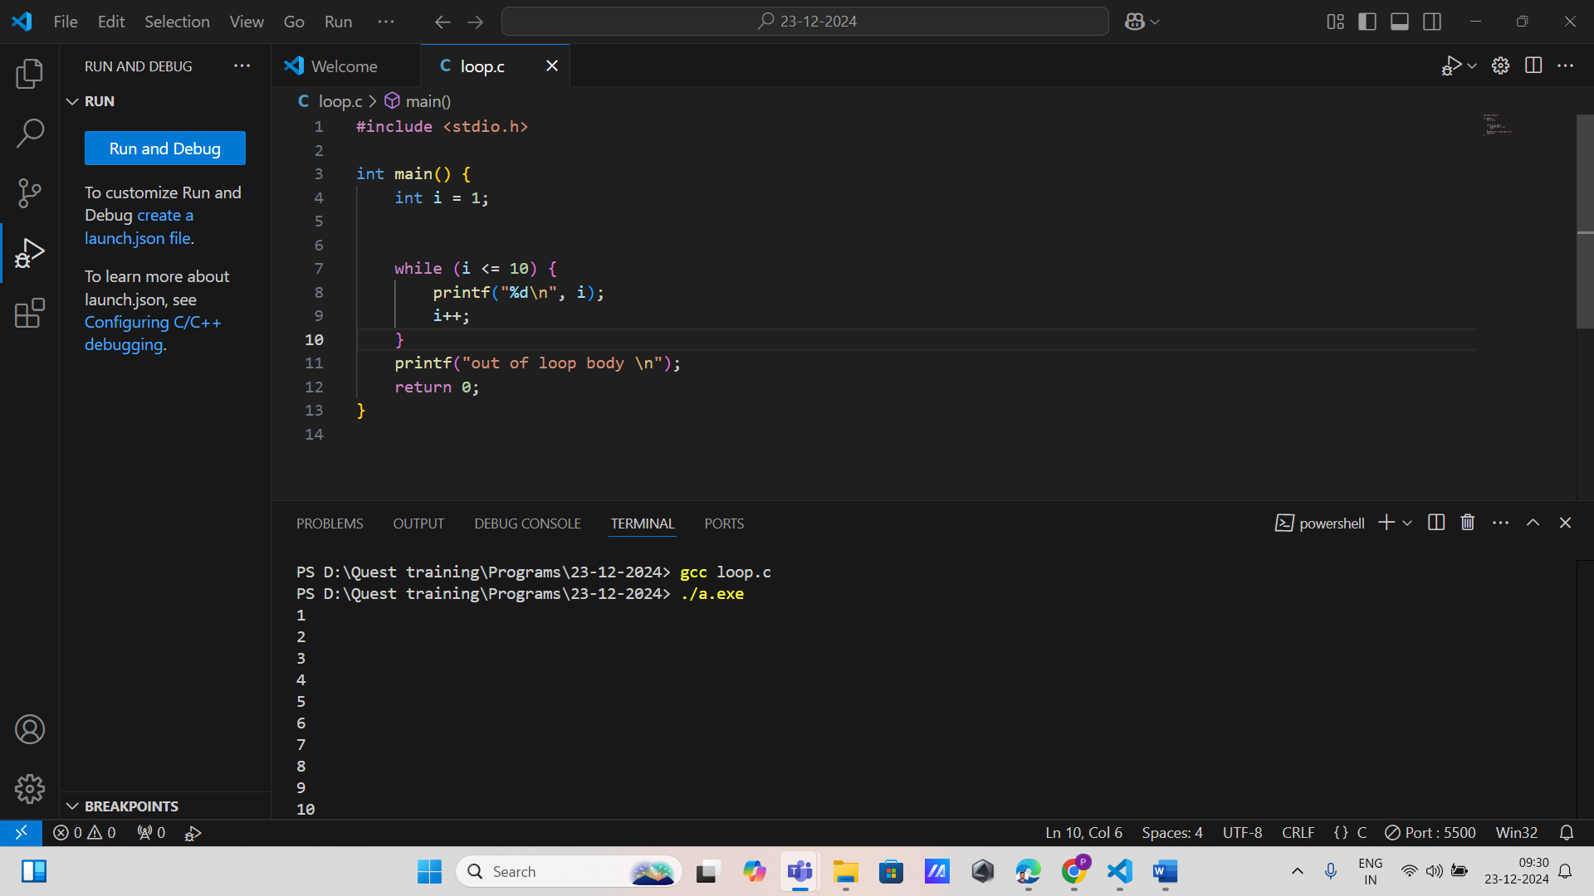

1. Write program in while loop for print the 0 to 100 even number and count that number and set the boundaries value.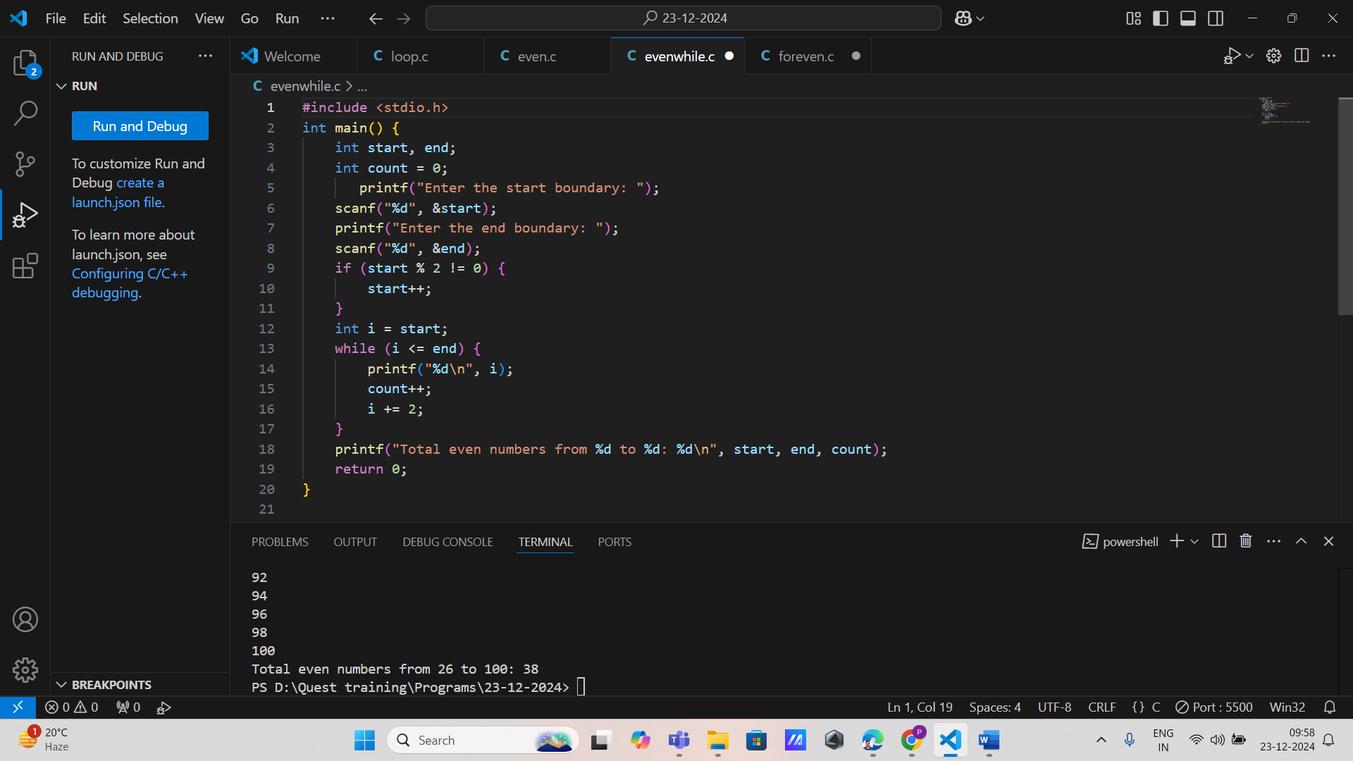
2. **Print Natural Numbers:**  
   Write a program to print the first 10 natural numbers using a while loop.

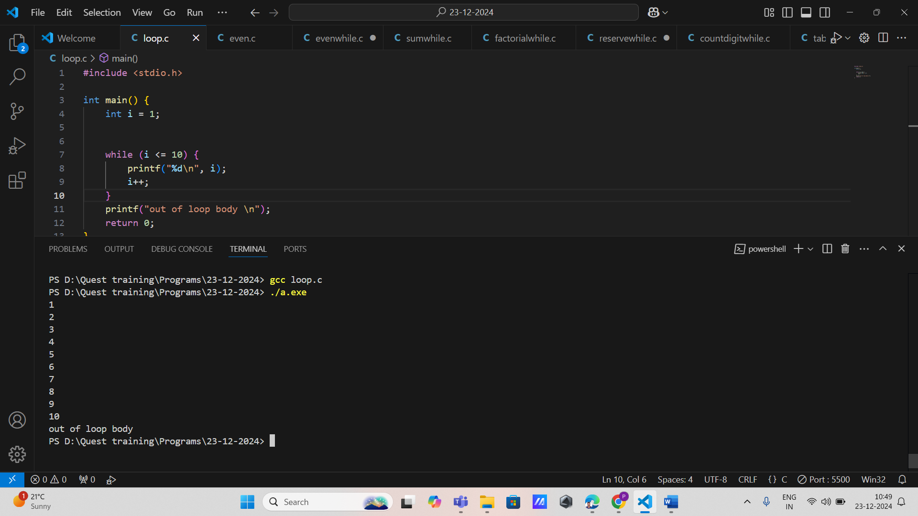

1. **Sum of Digits:**  
   Write a program to calculate the sum of the digits of a given integer using a while loop.

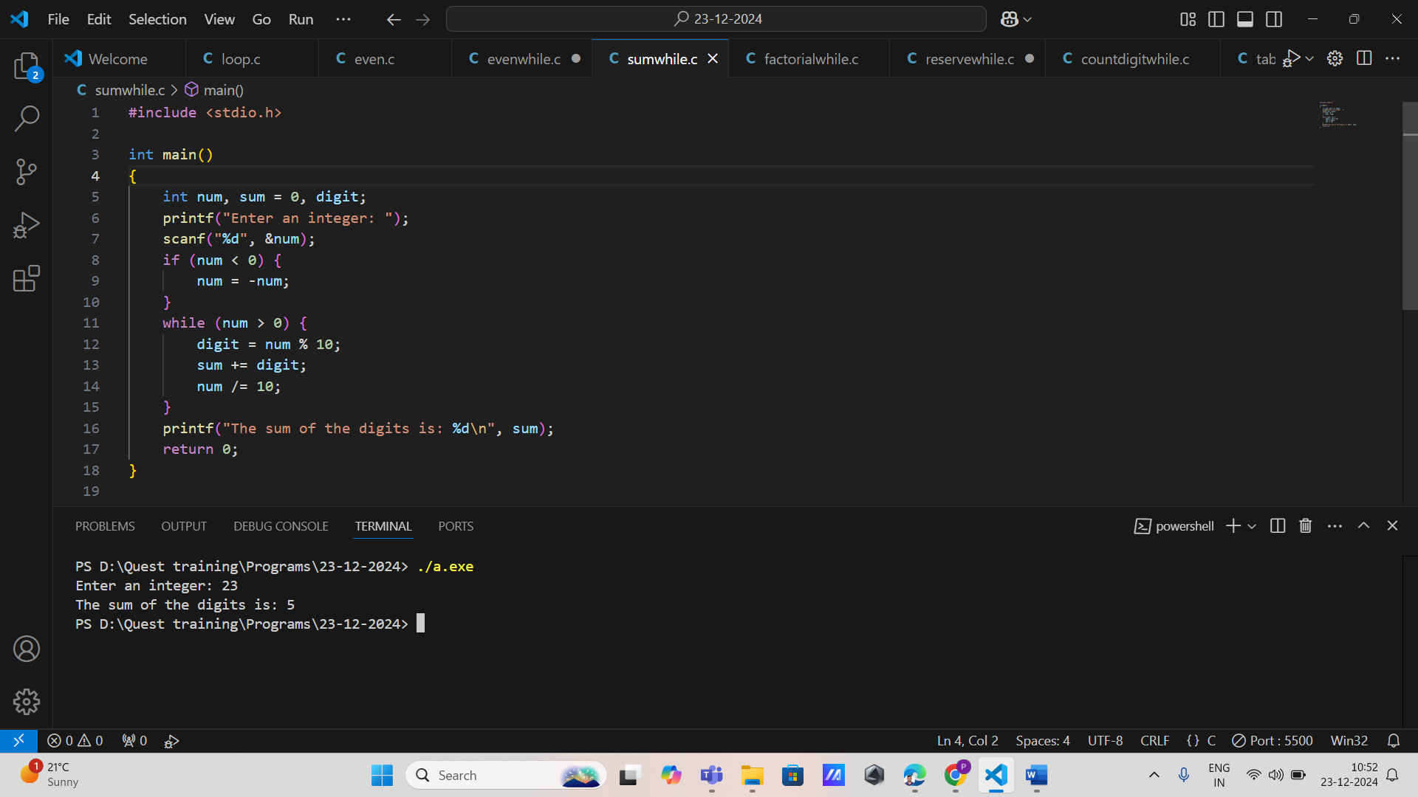

5. **Factorial of a Number:**  
Write a program to compute the factorial of a number using a while loop.

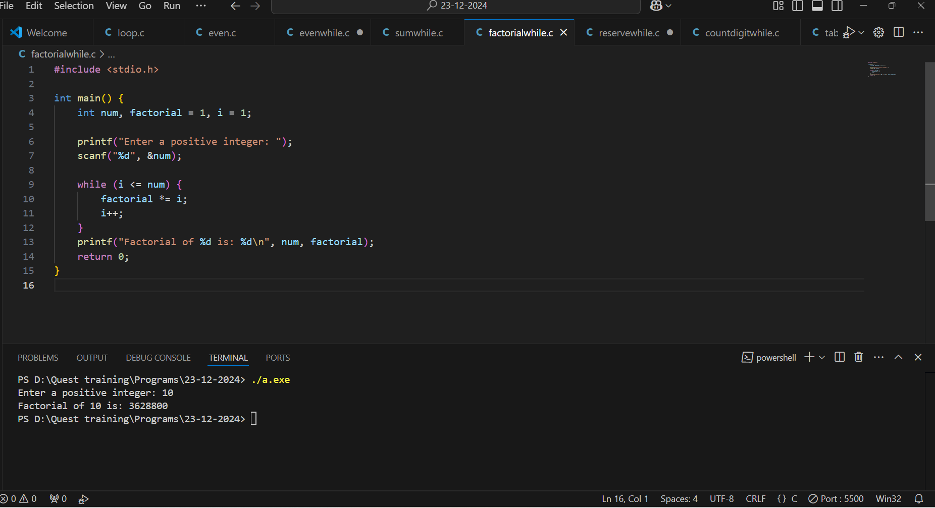

1. **Reverse a Number:**  
   Write a program to reverse a given number using a while loop.

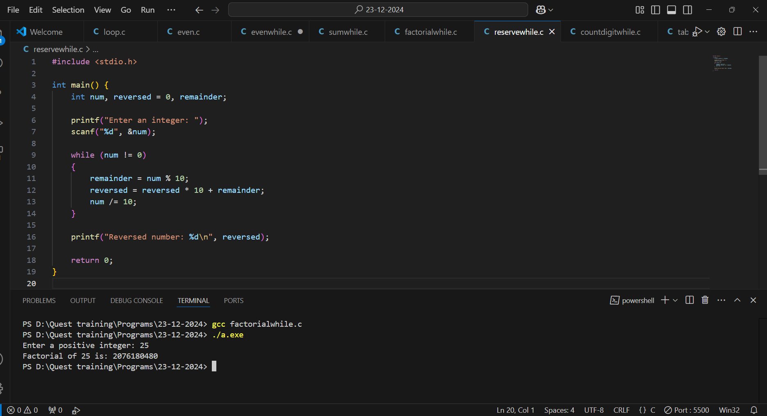

1. **Count Digits in a Number:**  
   Write a program to count the number of digits in an integer using a while loop.

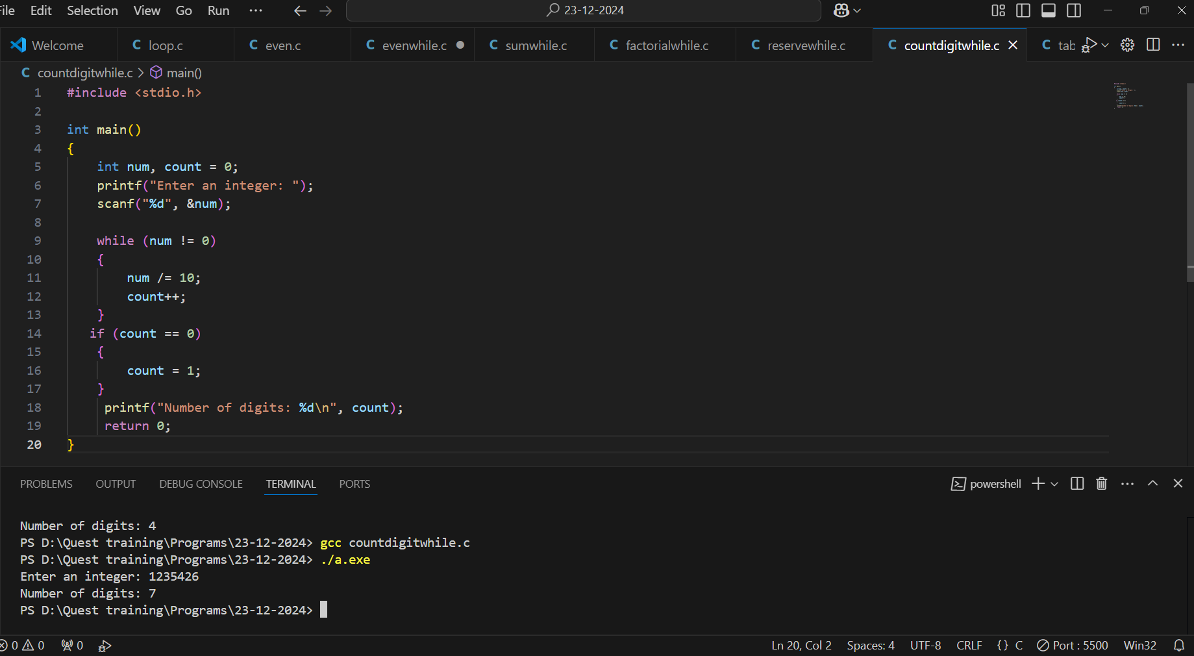

1. **Print Multiplication Table:**  
   Write a program to print the multiplication table of a given number using a while loop.

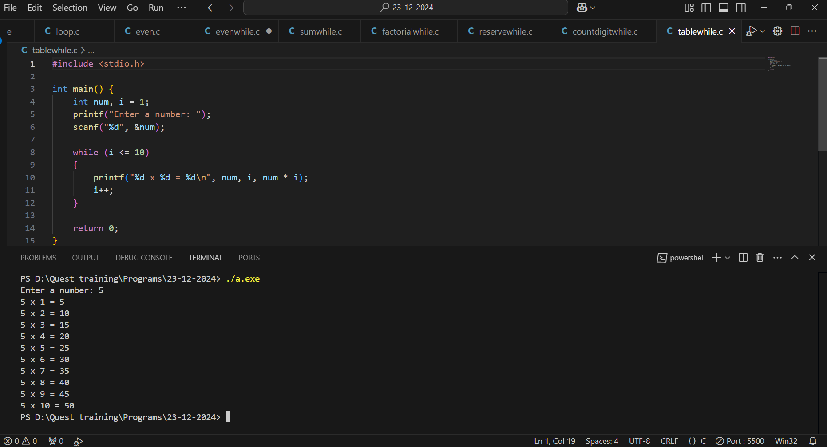

1. **Check Palindrome Number:**  
   Write a program to check if a number is a palindrome using a while loop.

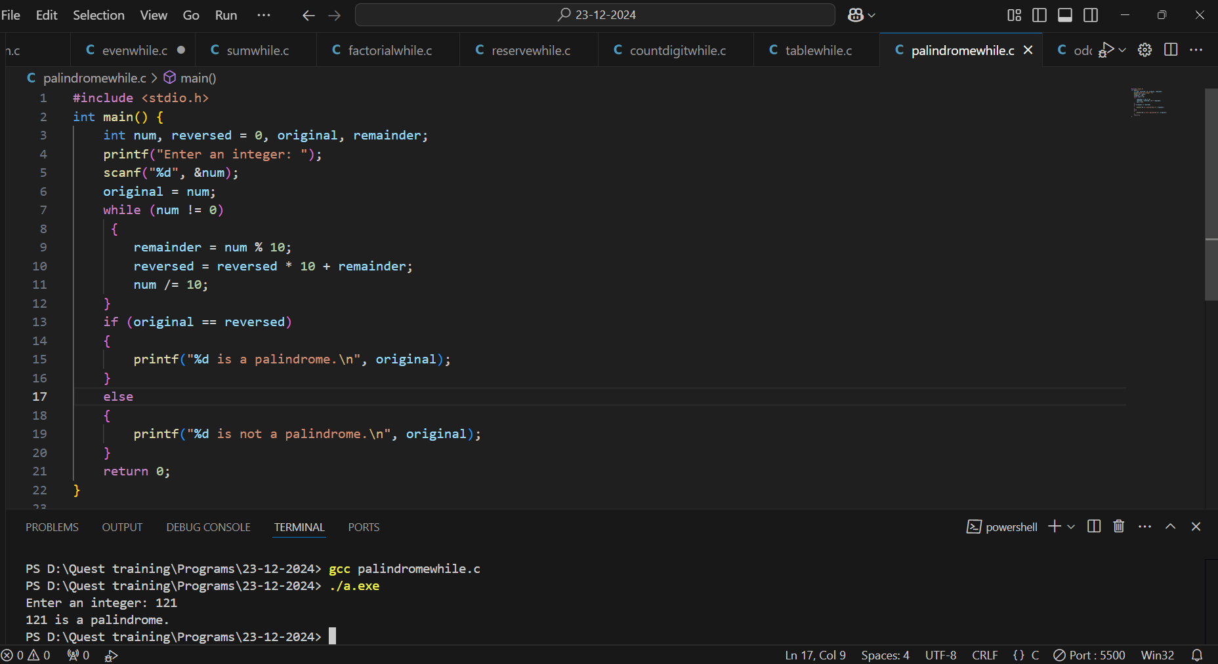

1. **Print Odd Numbers:**  
   Write a program to print all odd numbers between 1 and 50 using a while loop.

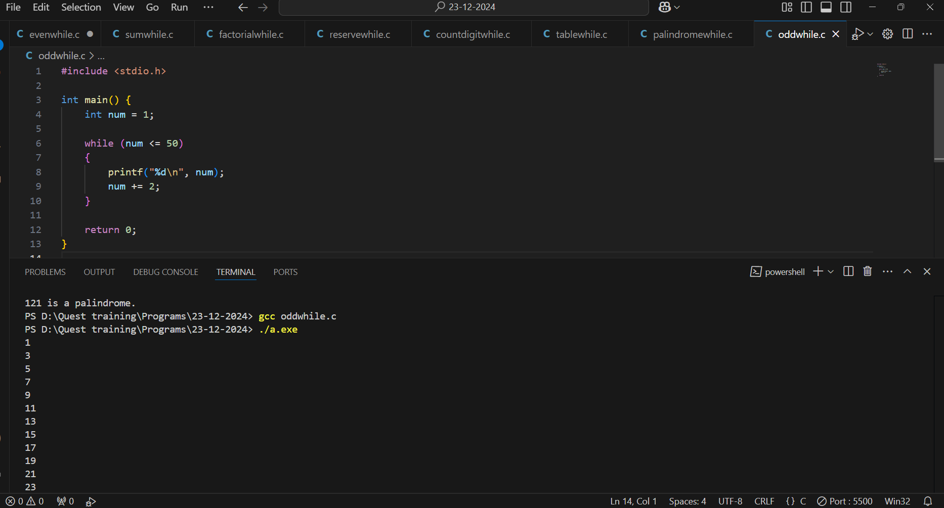

1. **Sum of Series:**  
   Write a program to calculate the sum of the series: S=1+2+3+…+n using a while loop.

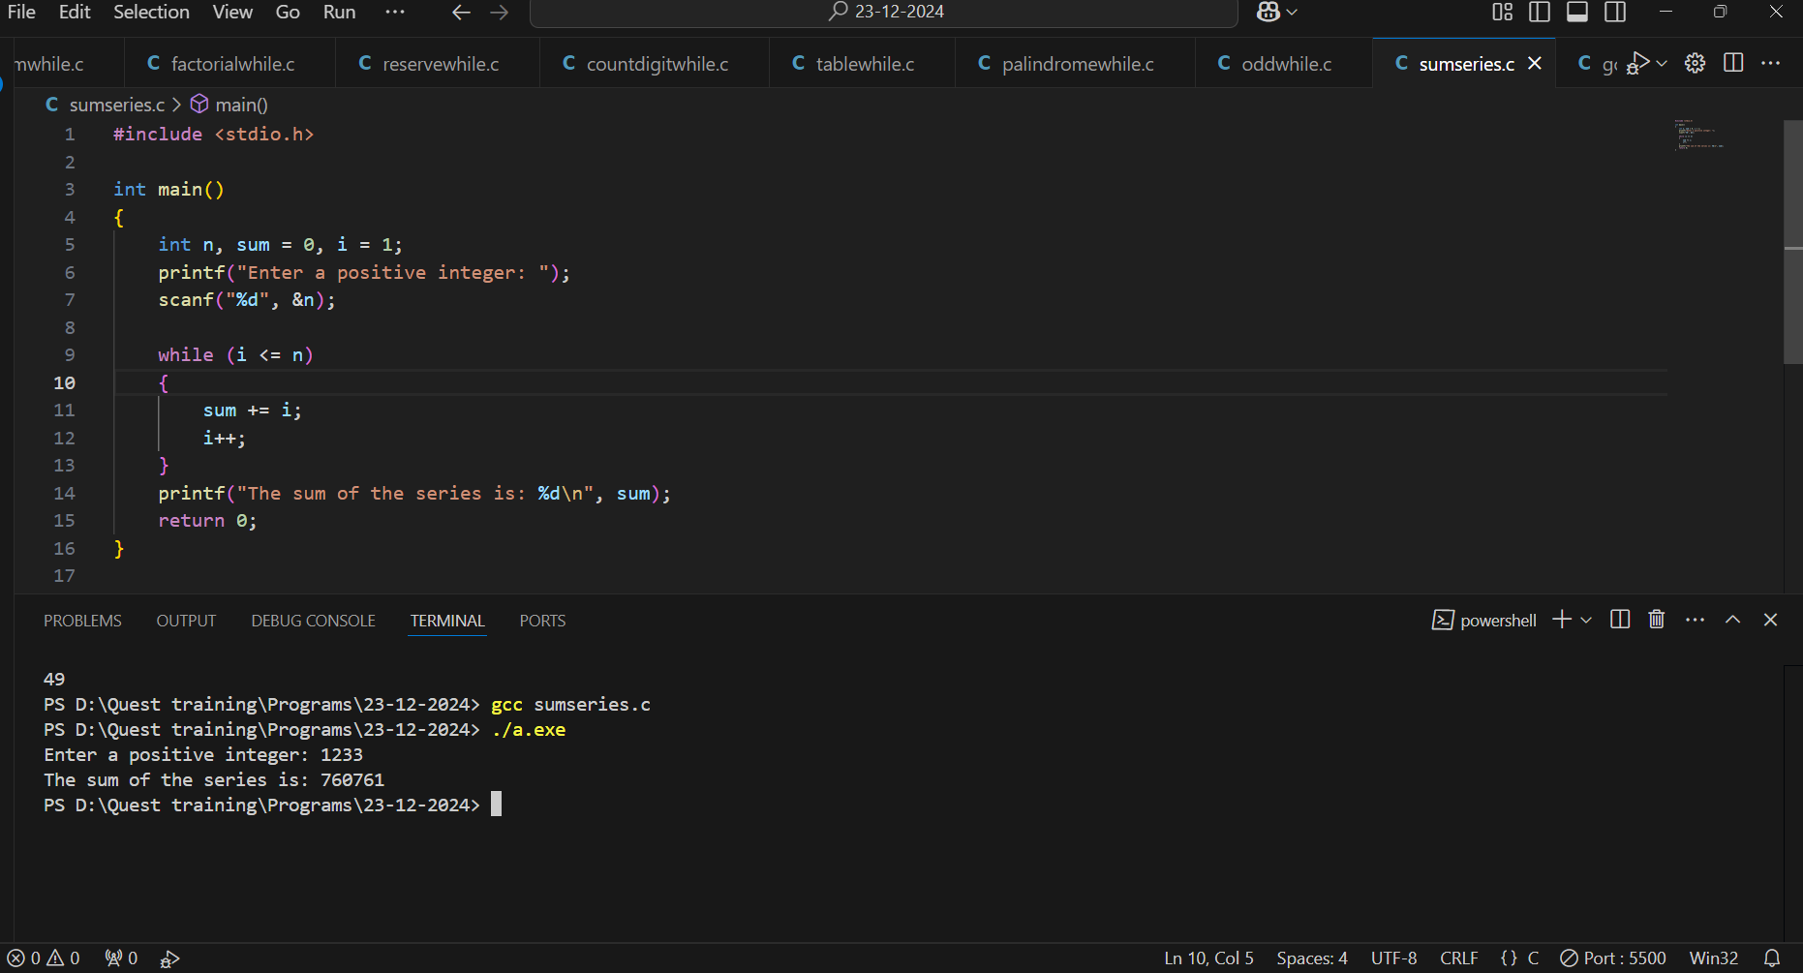

1. **Find GCD of Two Numbers:**  
   Write a program to compute the GCD of two numbers using a while loop.

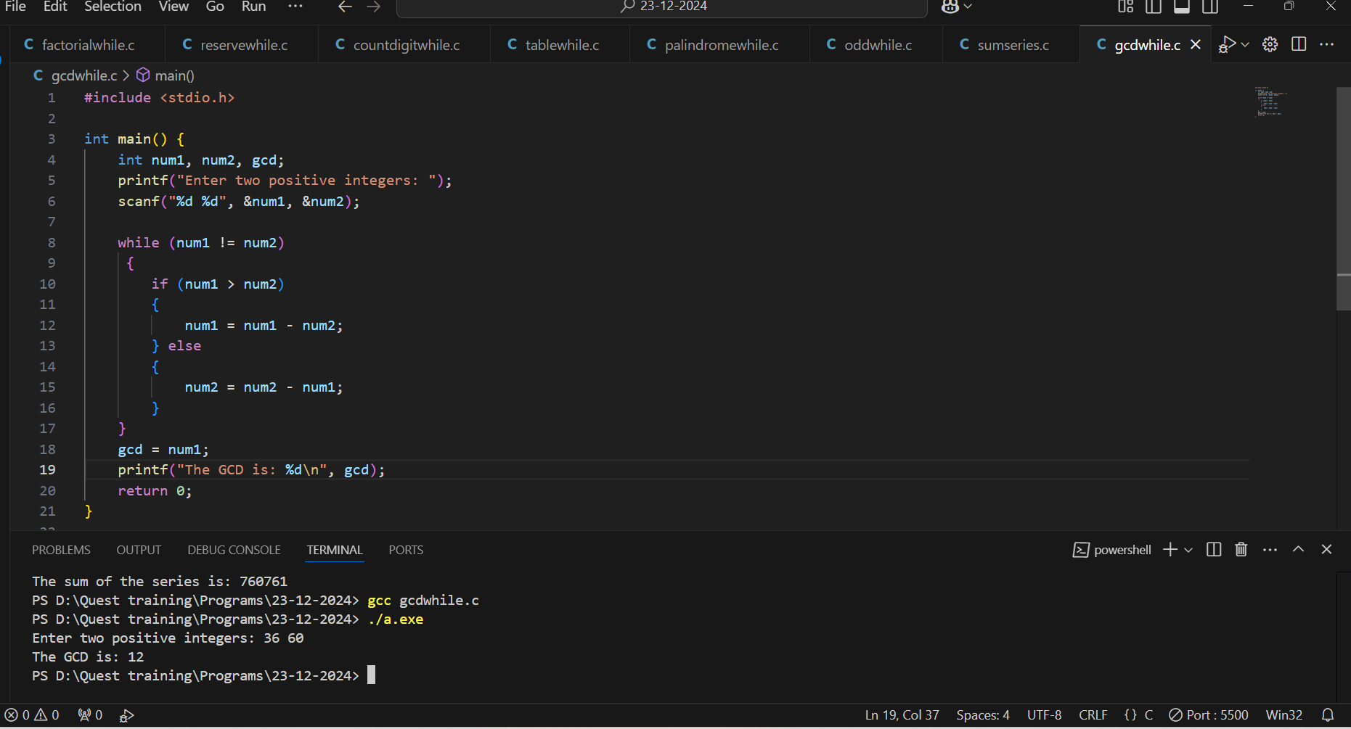

**FOR LOOP**

1. **Print Even Numbers:**  
   Write a program to print all even numbers between 1 and 100 using a for loop.

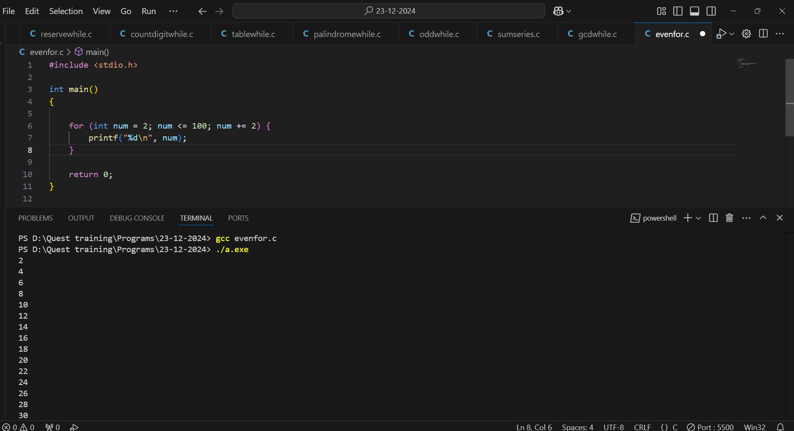

1. **Sum of First N Natural Numbers:**  
   Write a program to calculate the sum of the first nnn natural numbers using a for loop.

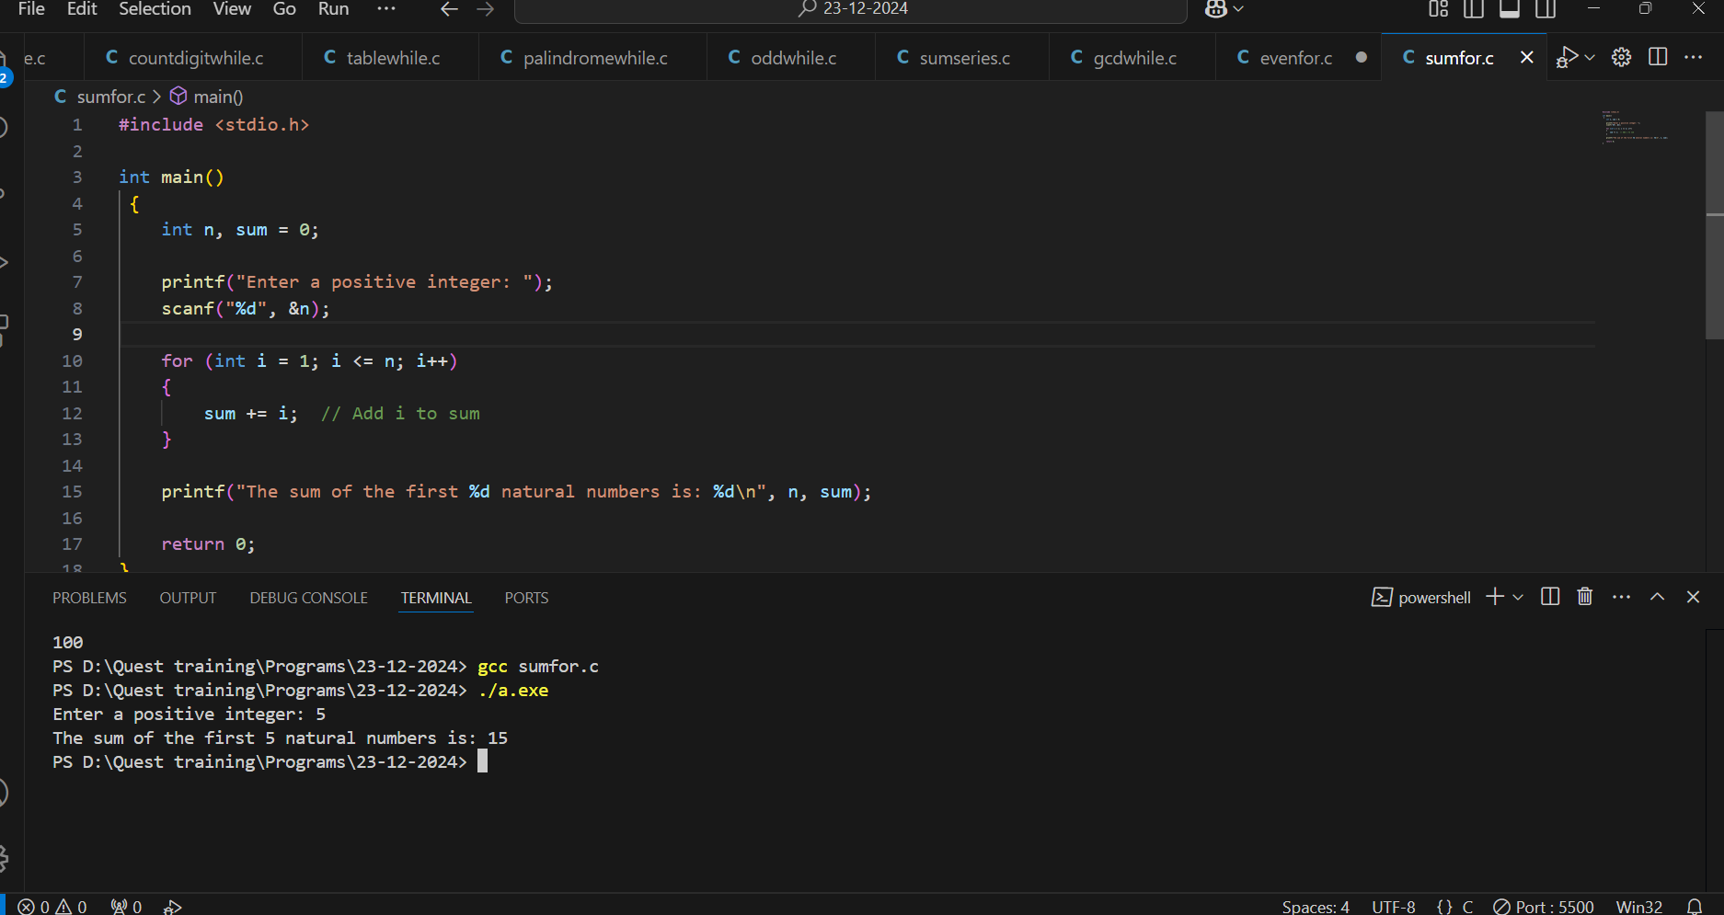

1. **Factorial of a Number:**  
   Write a program to calculate the factorial of a given number using a for loop.

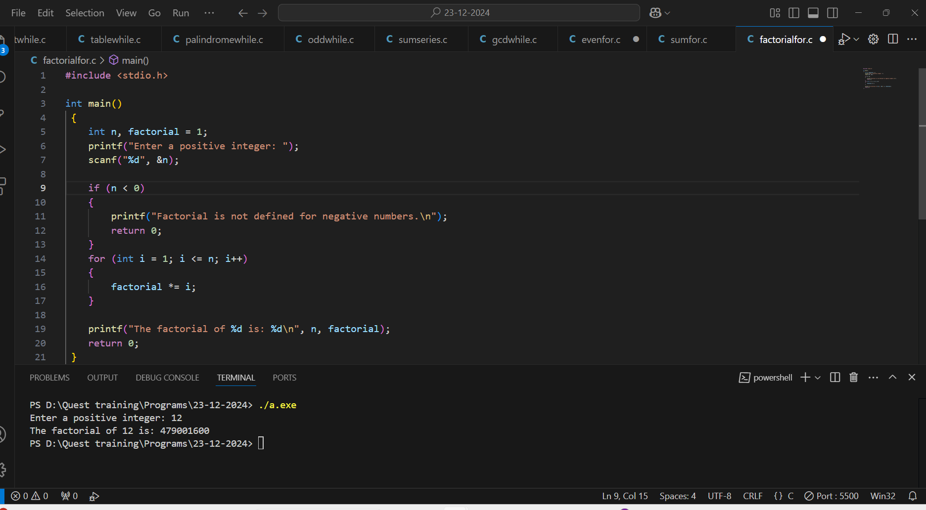

1. **Fibonacci Series:**  
   Write a program to generate the first nnn terms of the Fibonacci series using a for loop

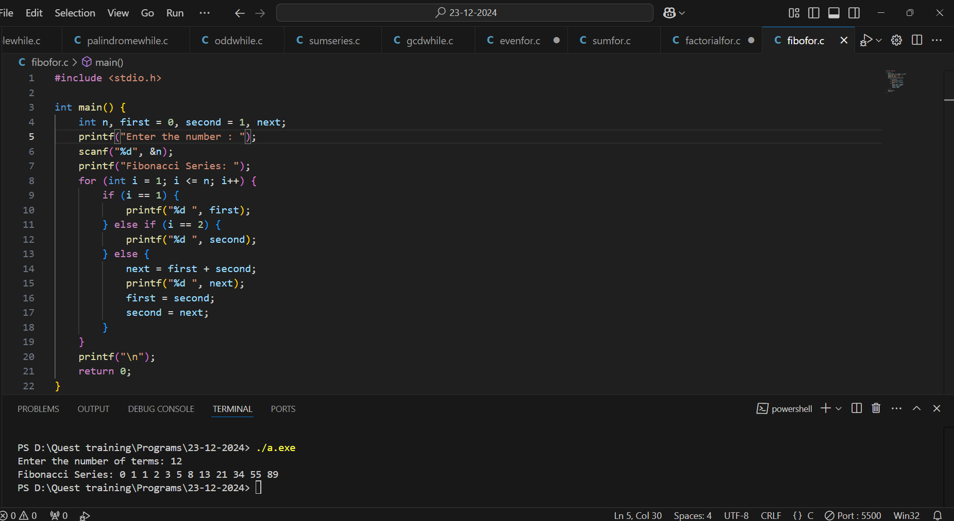

1. **Prime Number Check:**  
   Write a program to check if a given number is prime using a for loop.

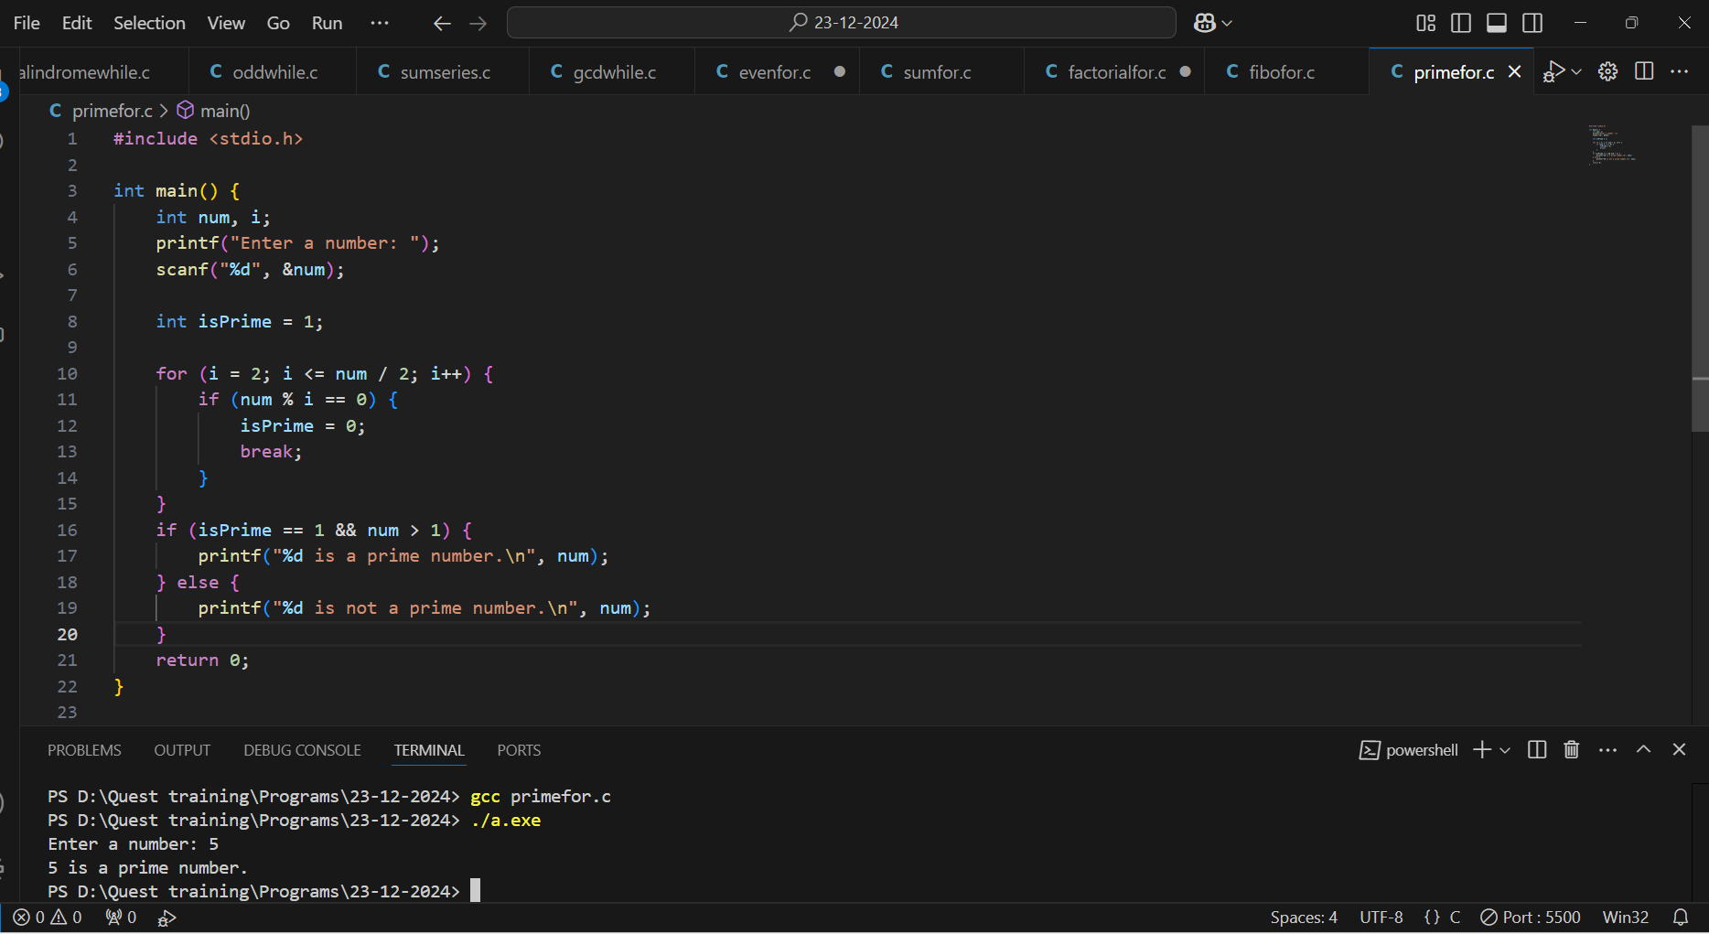

1. **Pattern Printing:**  
   Print the following pattern using a for loop: *

**

***

****

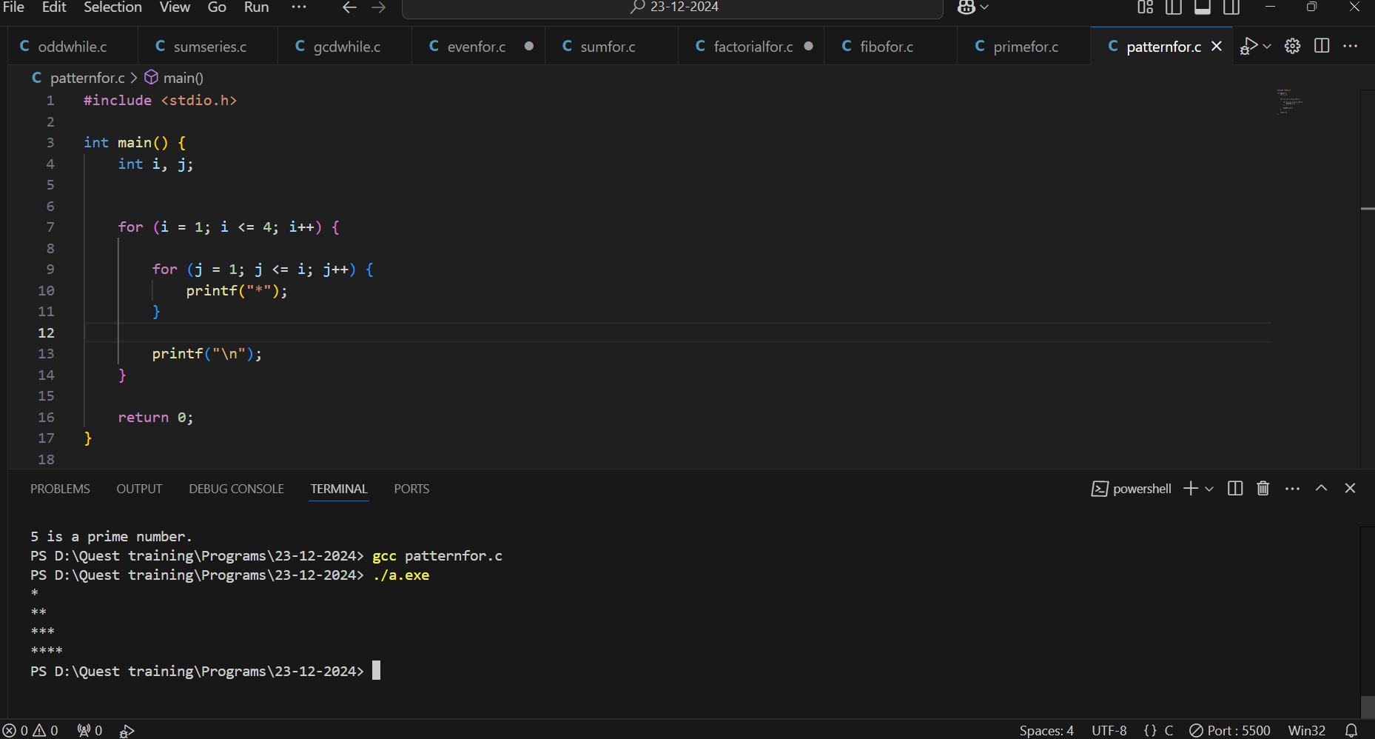

1. **Sum of Squares of Numbers:**  
   Write a program to calculate the sum of squares of the first nnn natural numbers using a for loop.

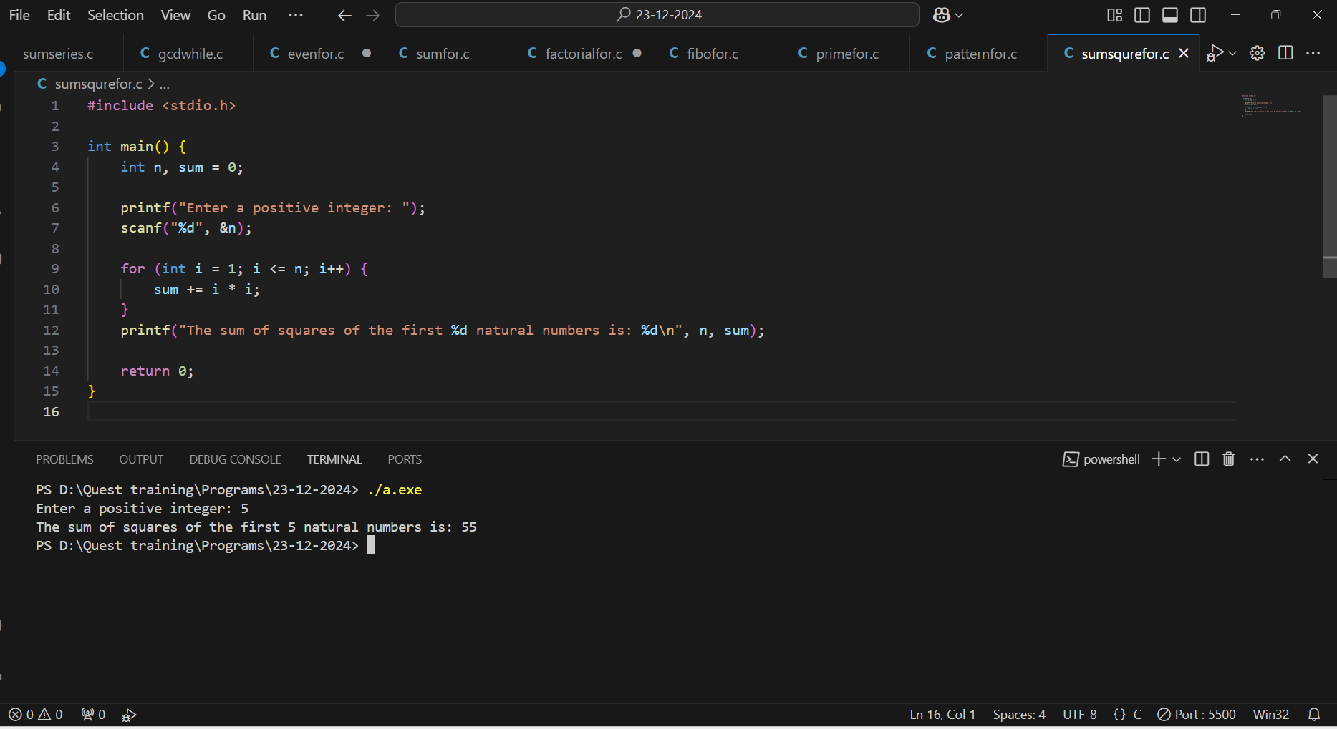

1. **Power of a Number:**  
   Write a program to compute (x raised to the power y) using a for loop.

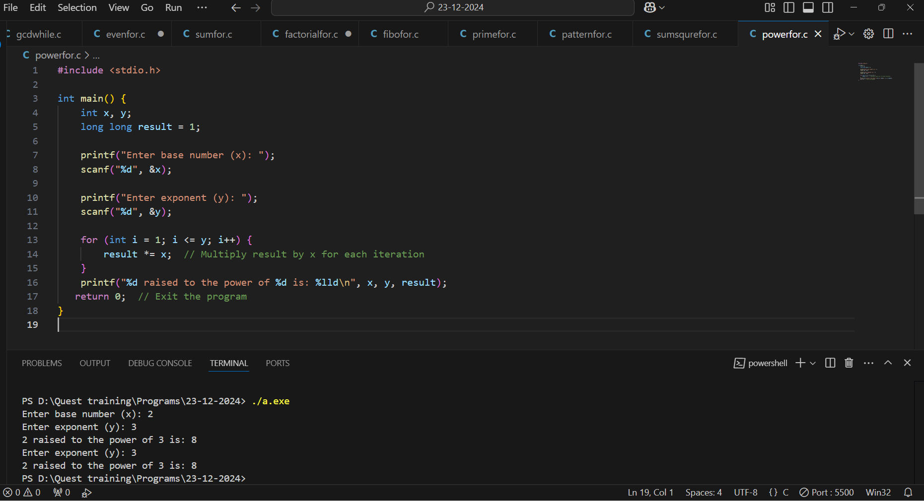

1. **Reverse Counting:**  
   Write a program to print numbers from 100 to 1 in reverse order using a for loop.

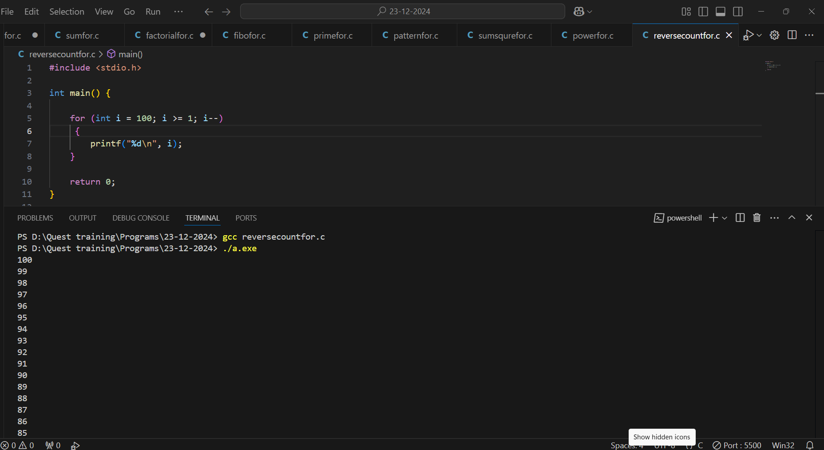

1. **Count Divisors of a Number:**  
   Write a program to count the divisors of a given number using a for loop.

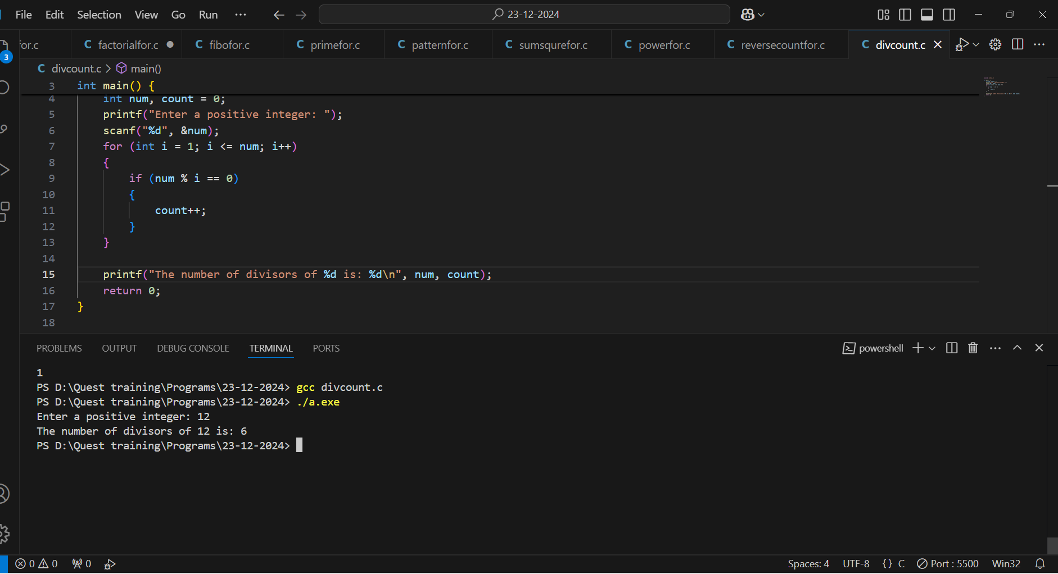

**DO WHILE LOOP**

1. Menu-Driven Calculator:

Write a menu-driven calculator using a do-while loop. Continue asking for user input until they choose to exit.

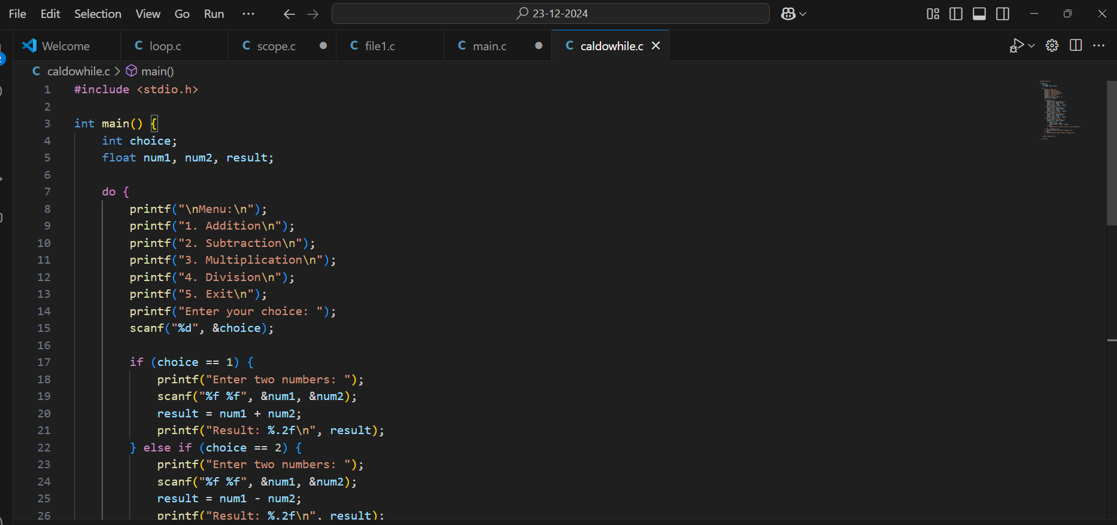

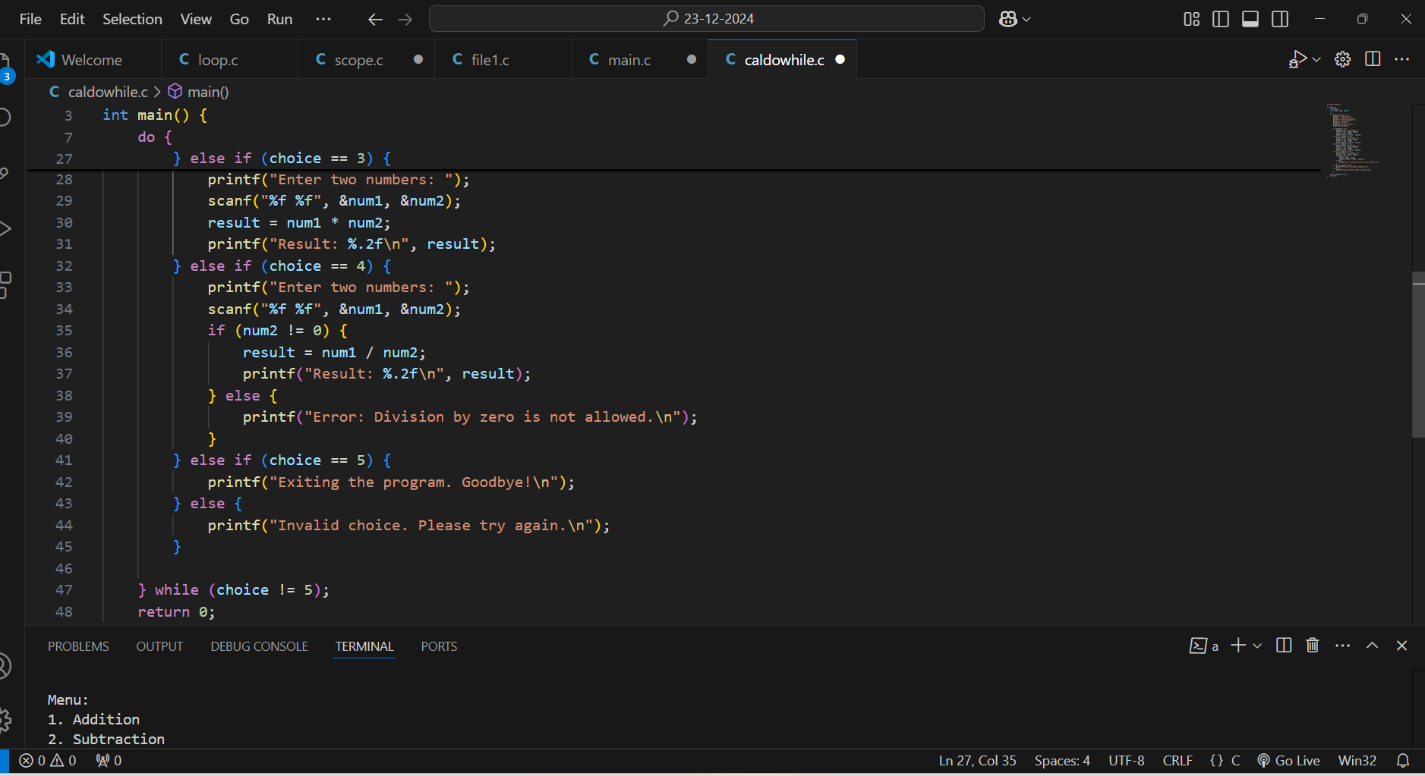

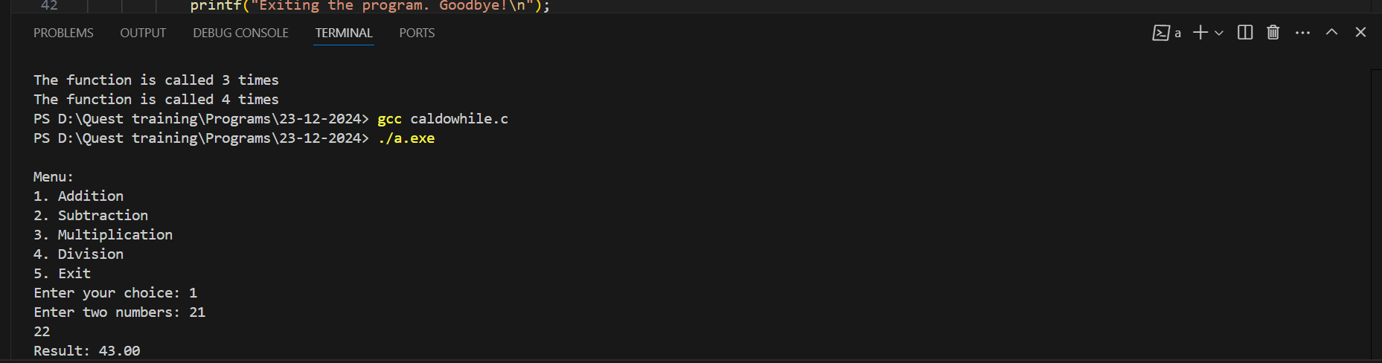

1. * Print Numbers Until Zero:

Write a program to keep accepting numbers from the user and print them until the user enters zero.

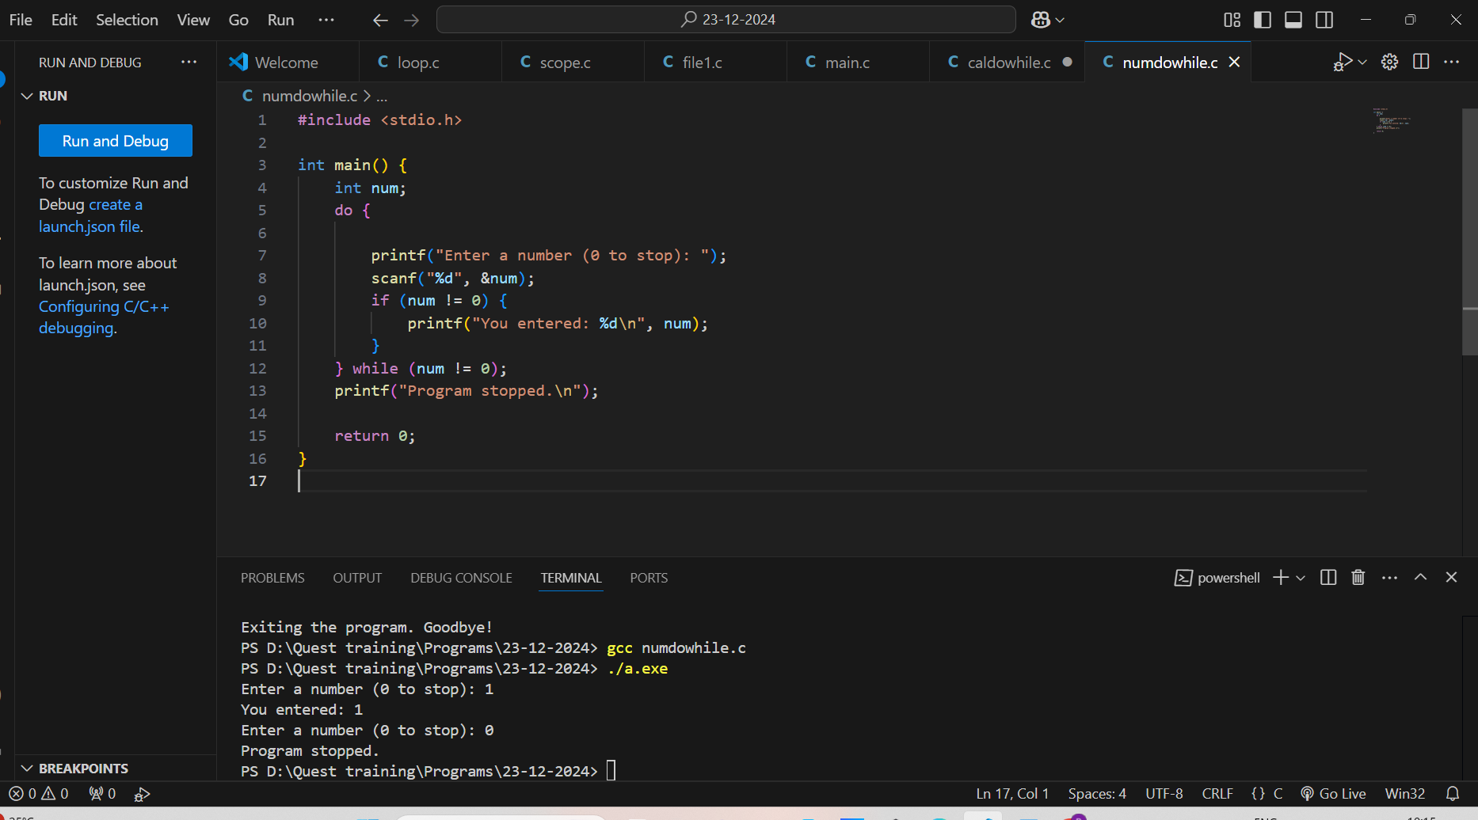

1. * Validate Password:

Write a program that asks for a password until the user provides the correct one using a do-while loop.

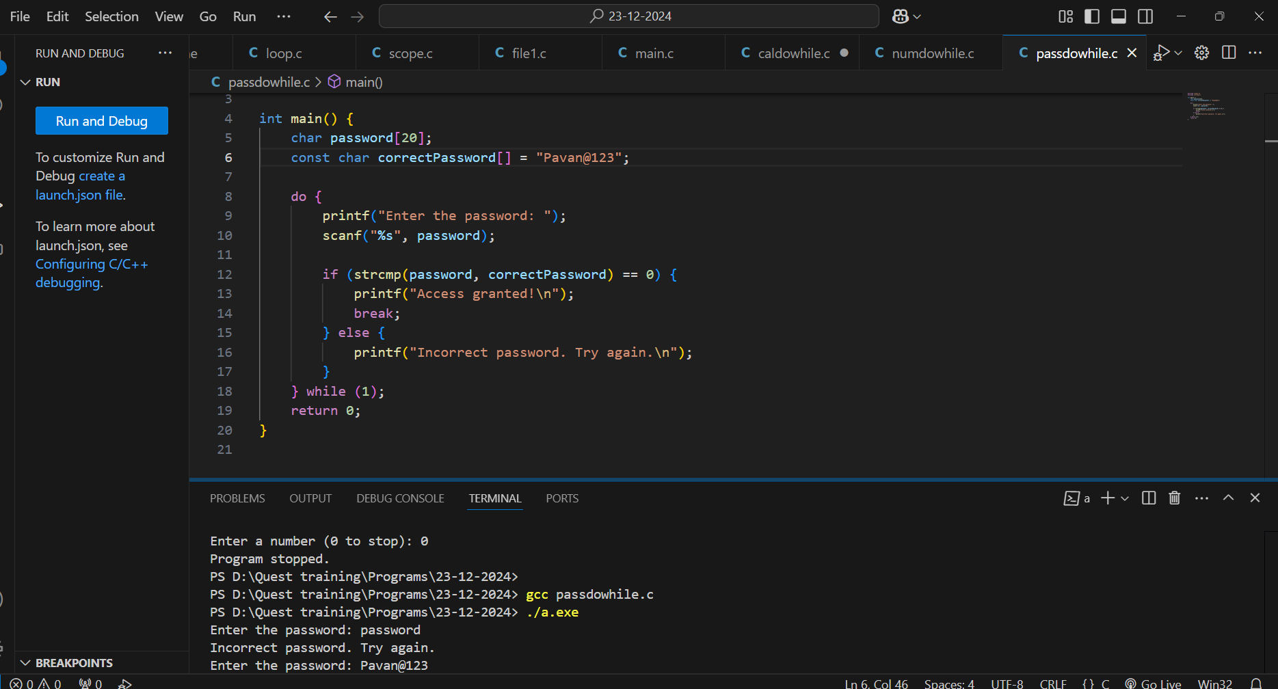

1. * Sum of Positive Numbers:

Write a program to read integers from the user and compute their sum. Stop when the user enters a negative number.

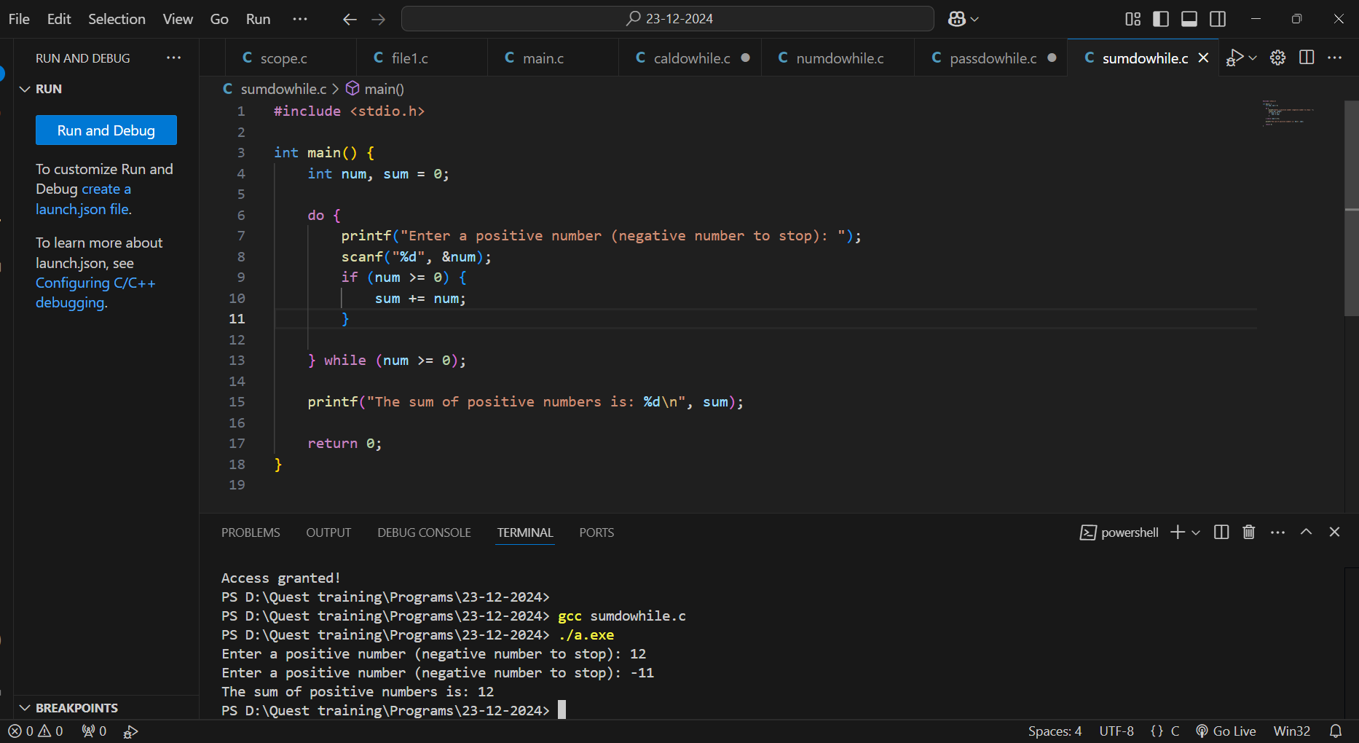

1. * Repeat Multiplication Table:

Write a program to repeatedly display the multiplication table of a number until the user decides to stop.

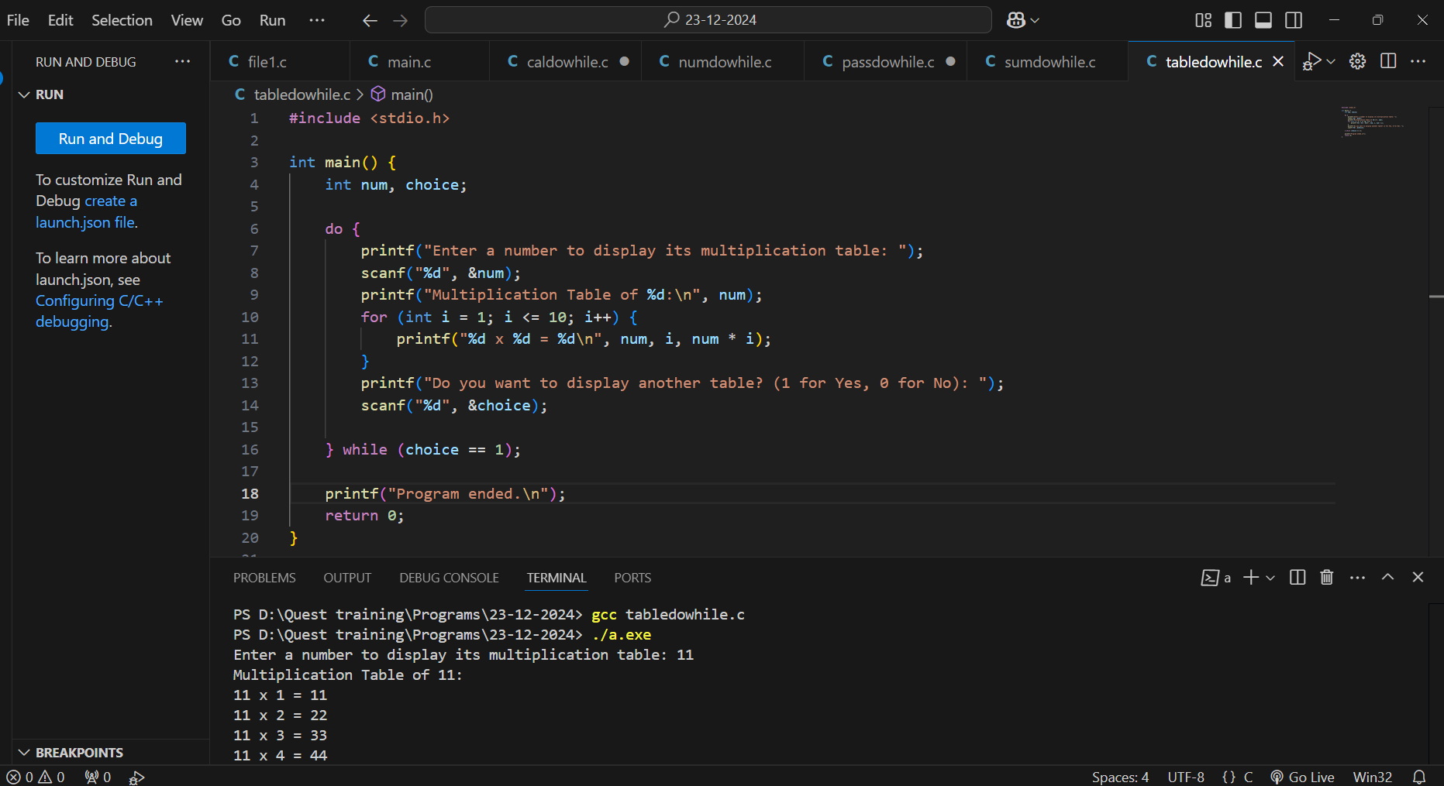

27. * Guess the Number Game:

Write a program where the user guesses a predefined number. Continue the game until the correct number is guessed.

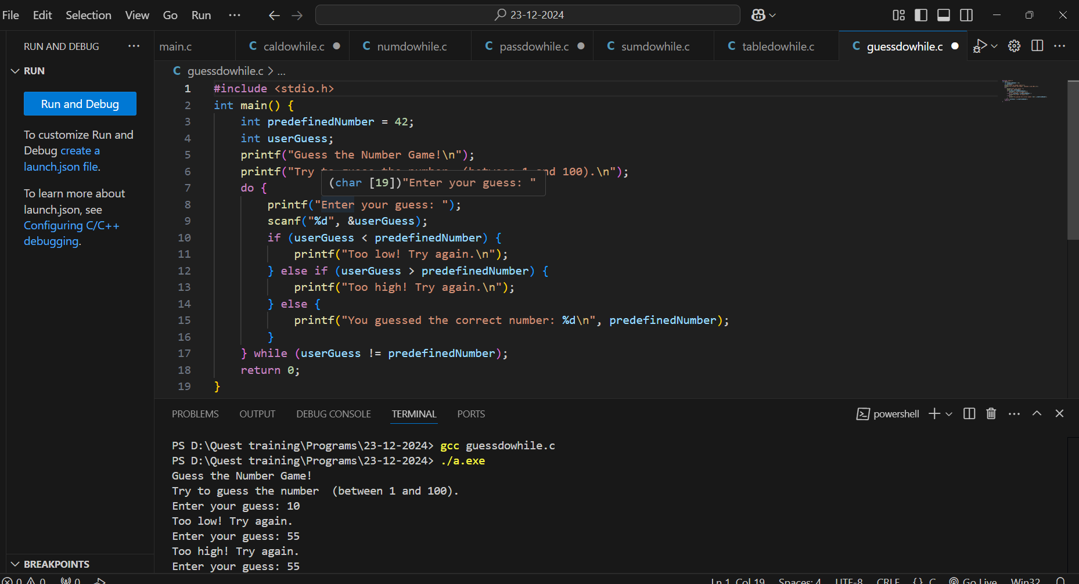

28. * Input Validation:

Write a program to ensure that the user enters a number between 1 and 10. Prompt until a valid number is provided.

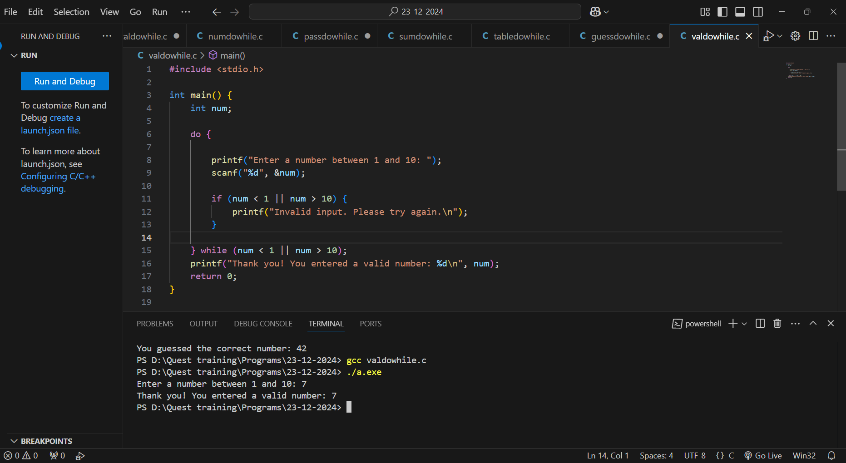

29. * Calculate Average:

Write a program to calculate the average of a series of numbers entered by the user. Stop when the user enters zero.

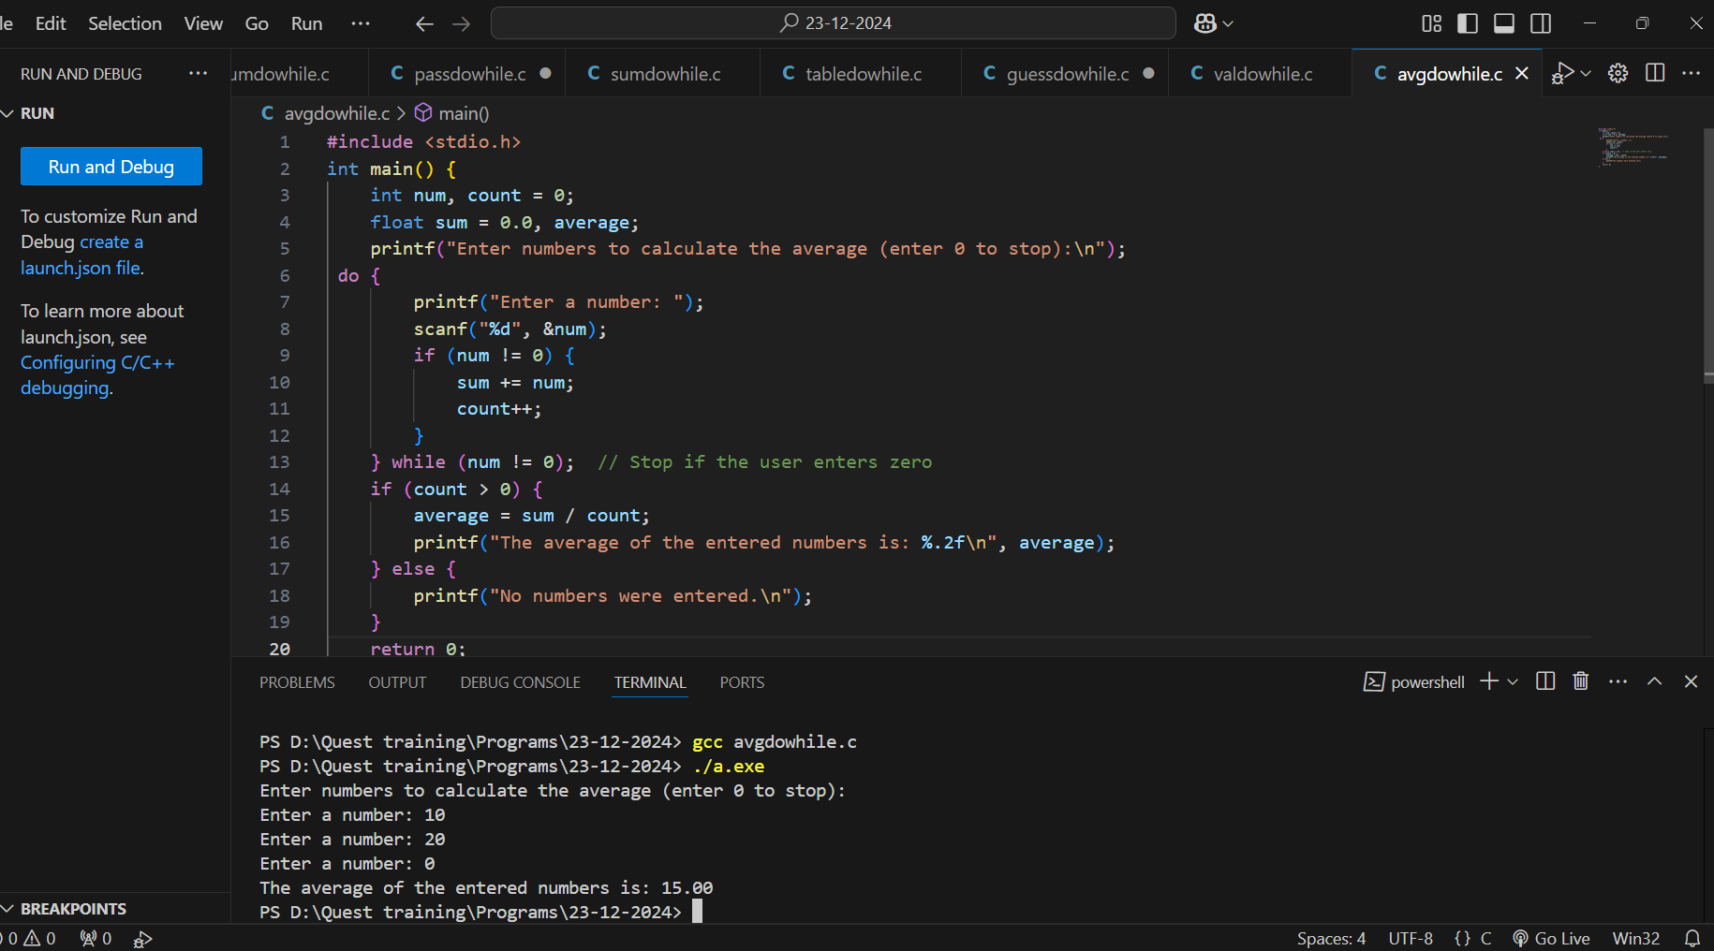

30. * Print Alphabets:

Write a program to print lowercase alphabets from 'a' to 'z' using a do-while loop.

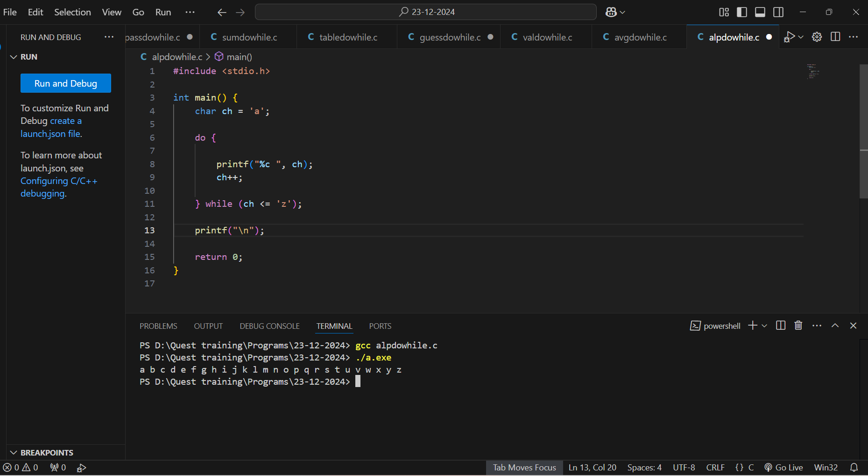

31. * Count Digits of a Number:

Write a program to count the number of digits in a number entered by the user using a do-while loop.

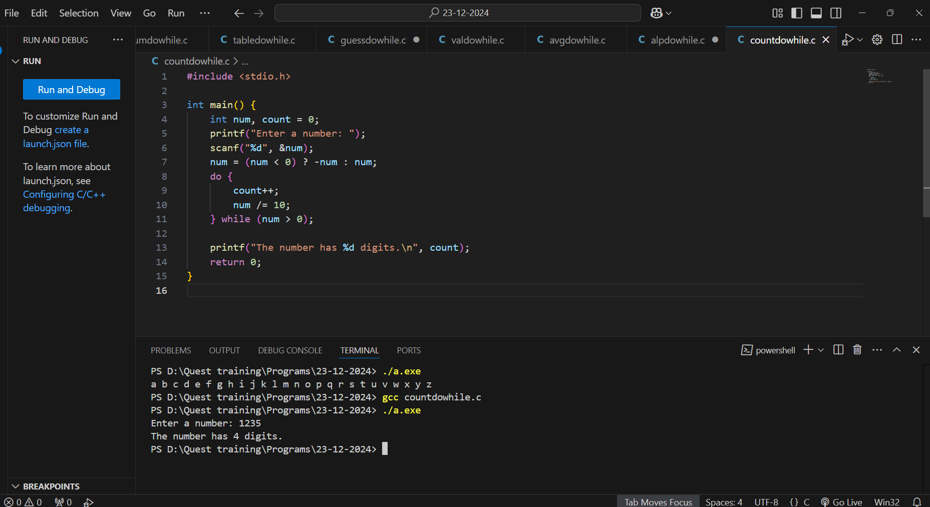

**1. Pascal’s Triangle**

**1**

**1 1**

**1 2 1**

**1 3 3 1**

**1 4 6 4 1**

**#FOR LOOP**

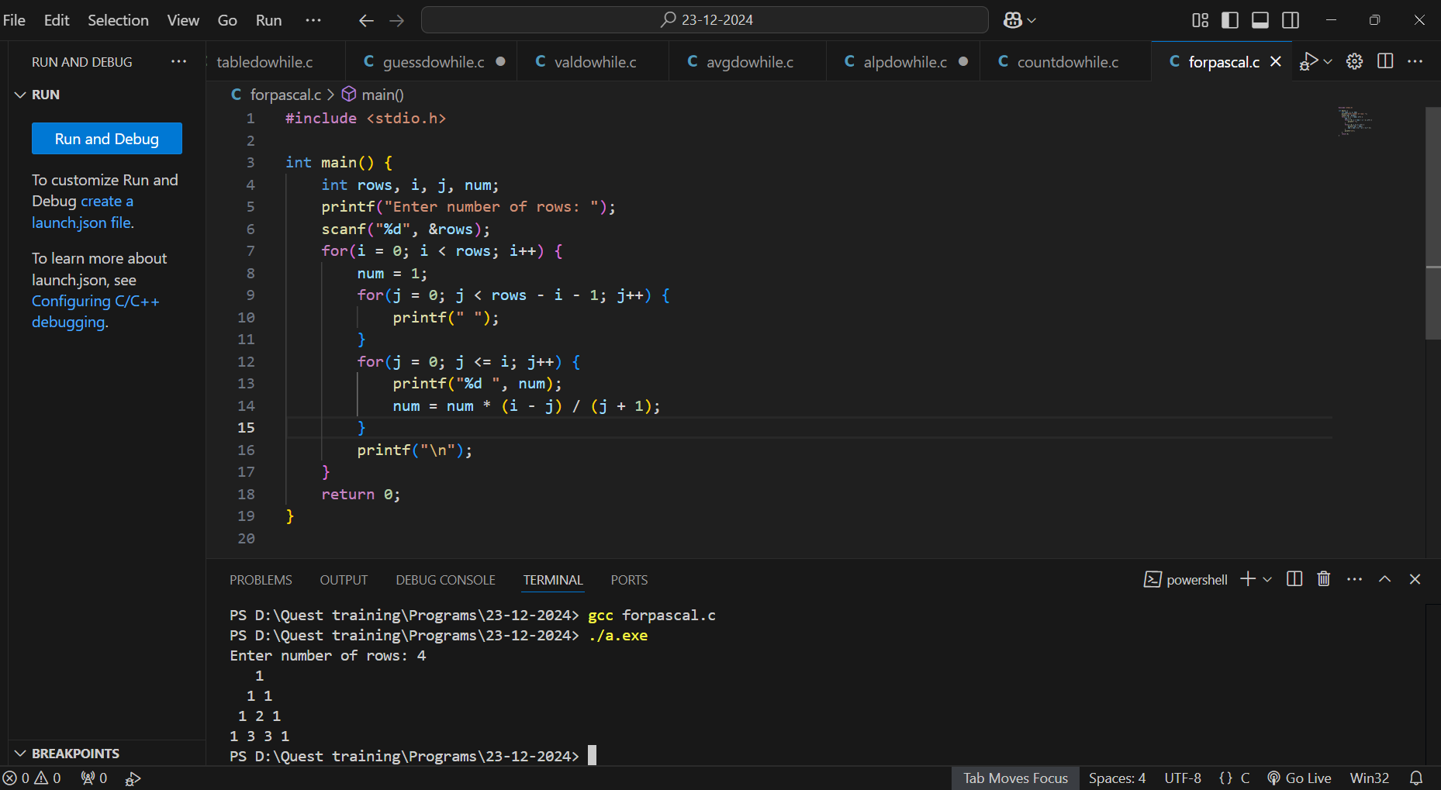

**#While Loop**

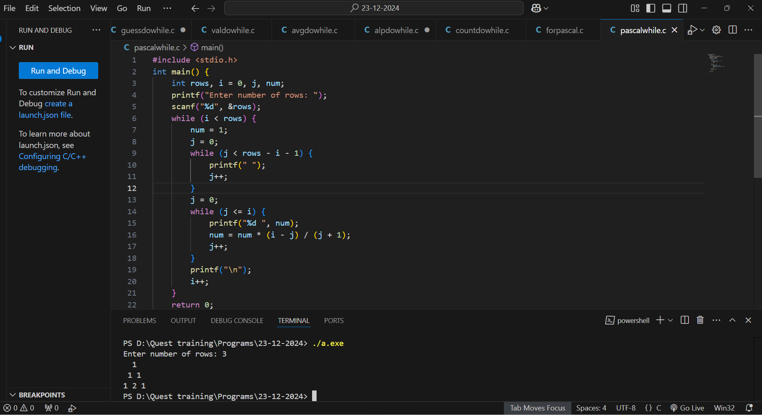

**2. Binary Pattern**

**1**

**01**

**101**

**0101**

**10101**

**#FOR LOOP**

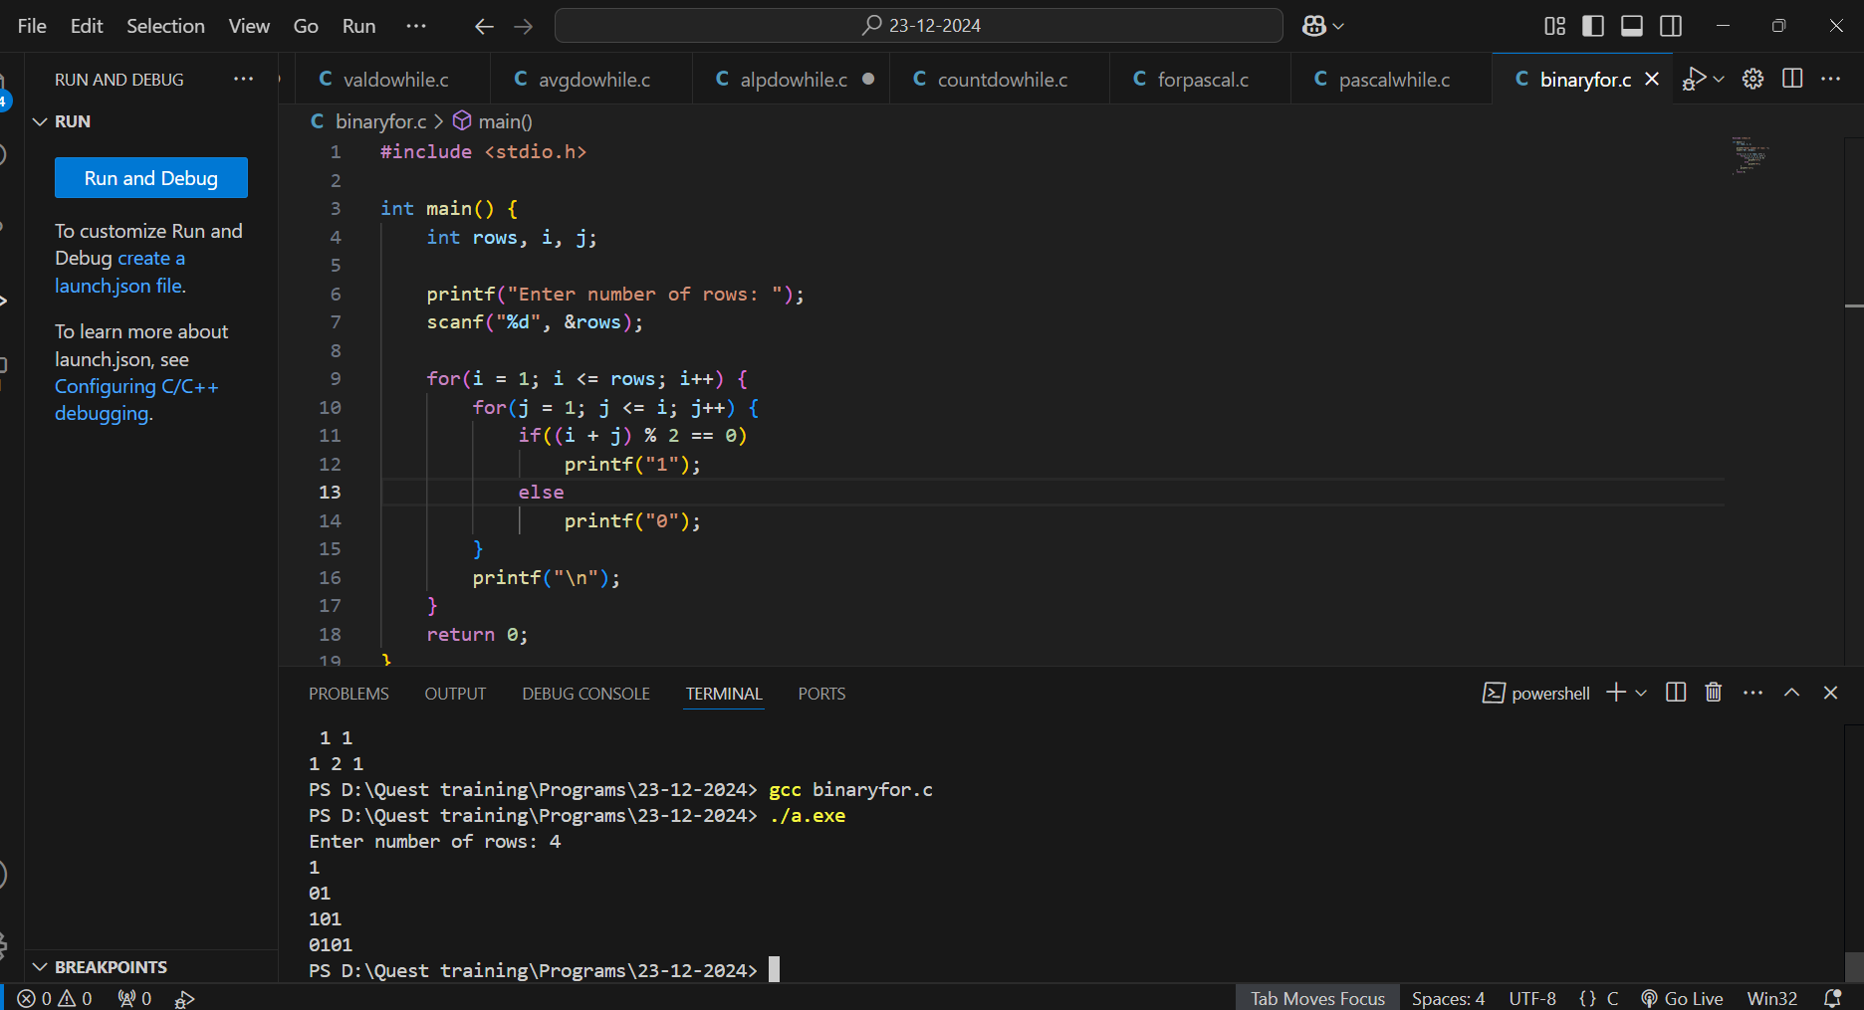

**#WHILE LOOP**

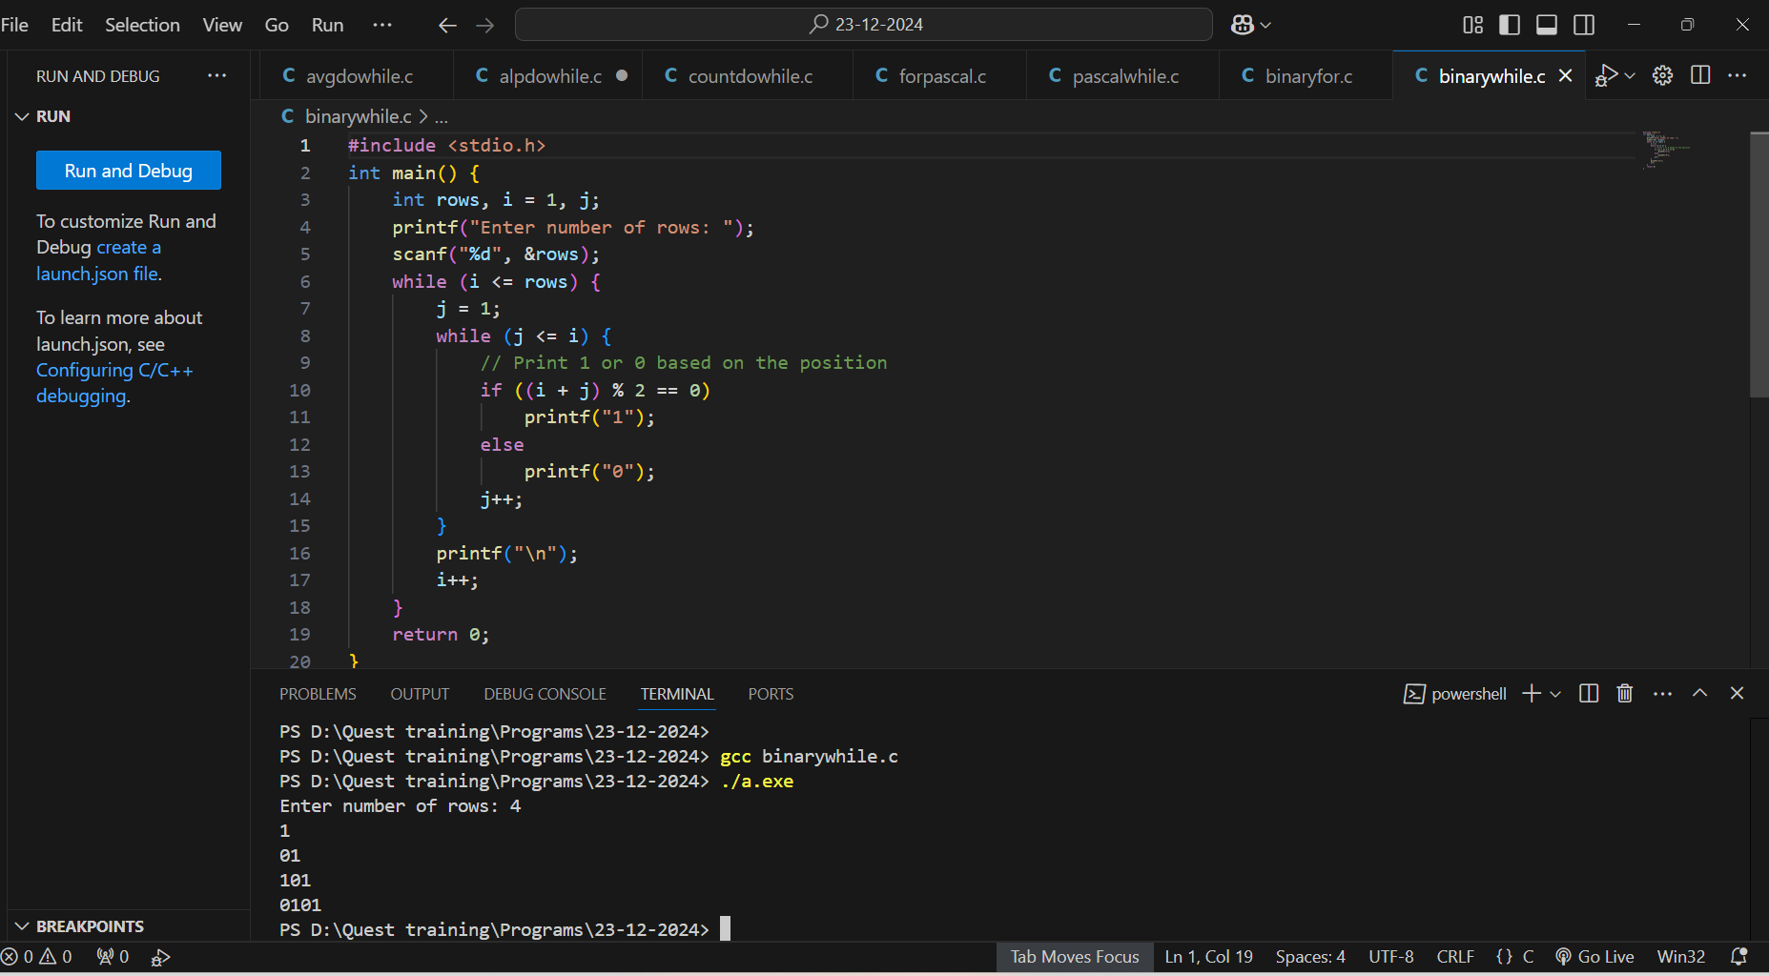

**3. Floyd’s Triangle (Numbers)**

**1**

**2 3**

**4 5 6**

**7 8 9 10**

**11 12 13 14 15**

**#FOR LOOP  
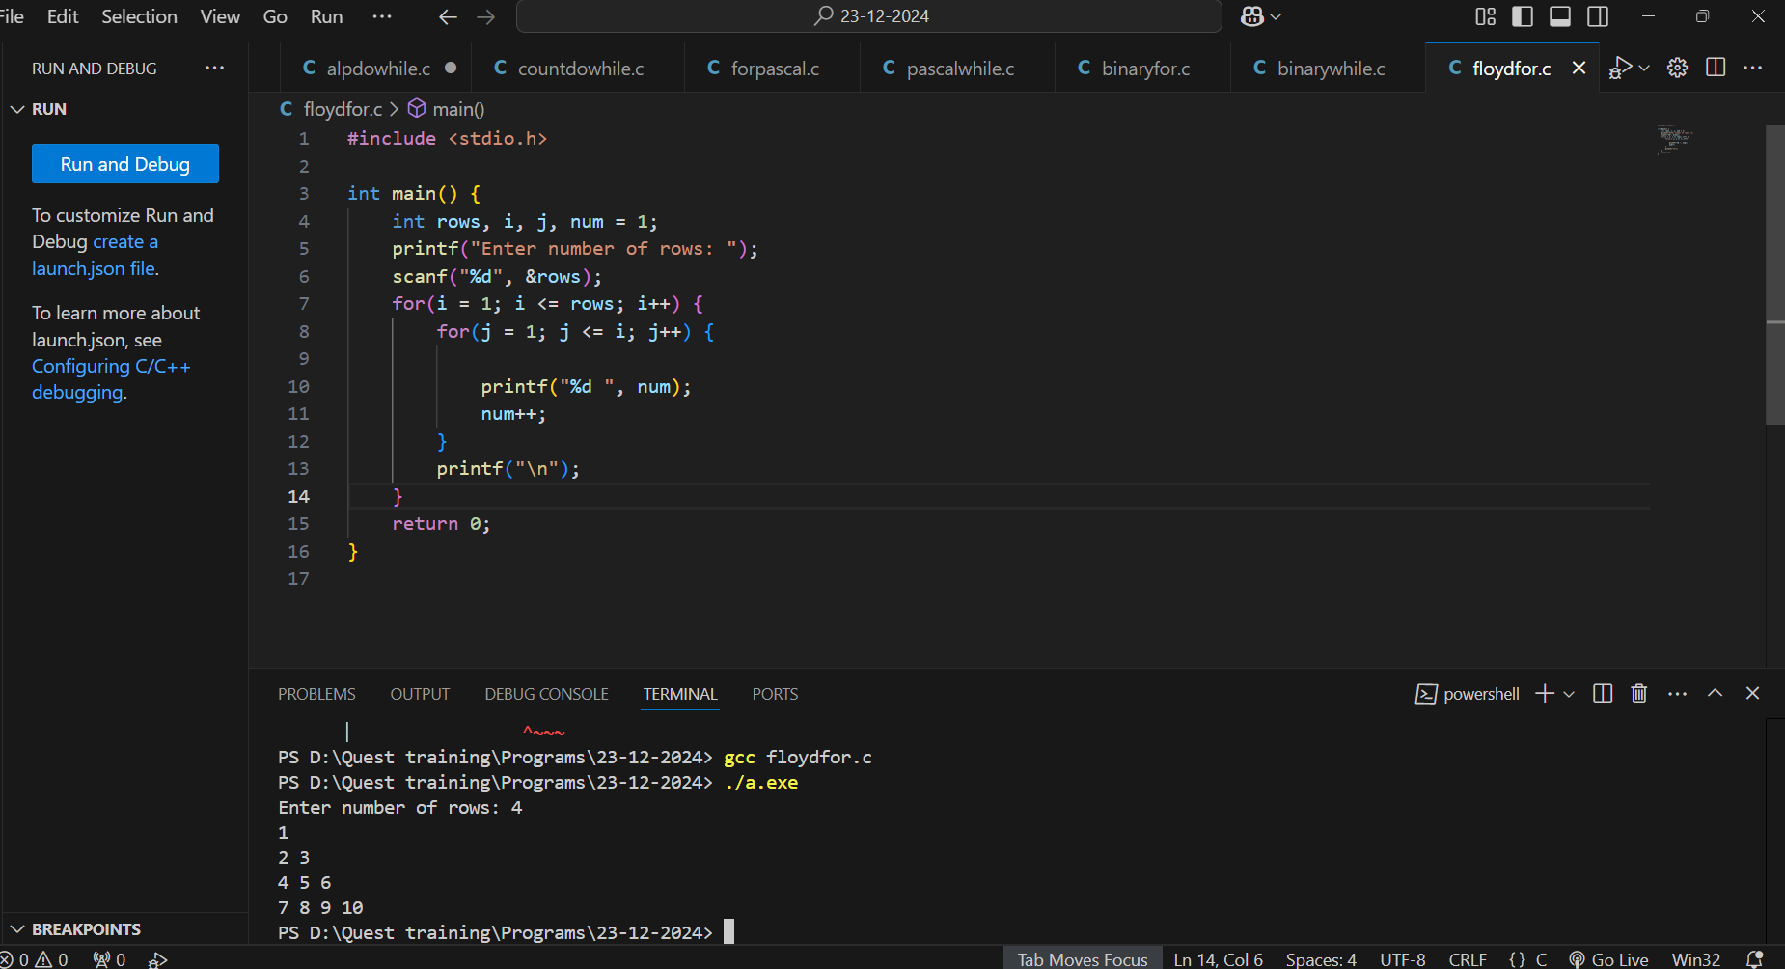**

**#WHILE LOOP**

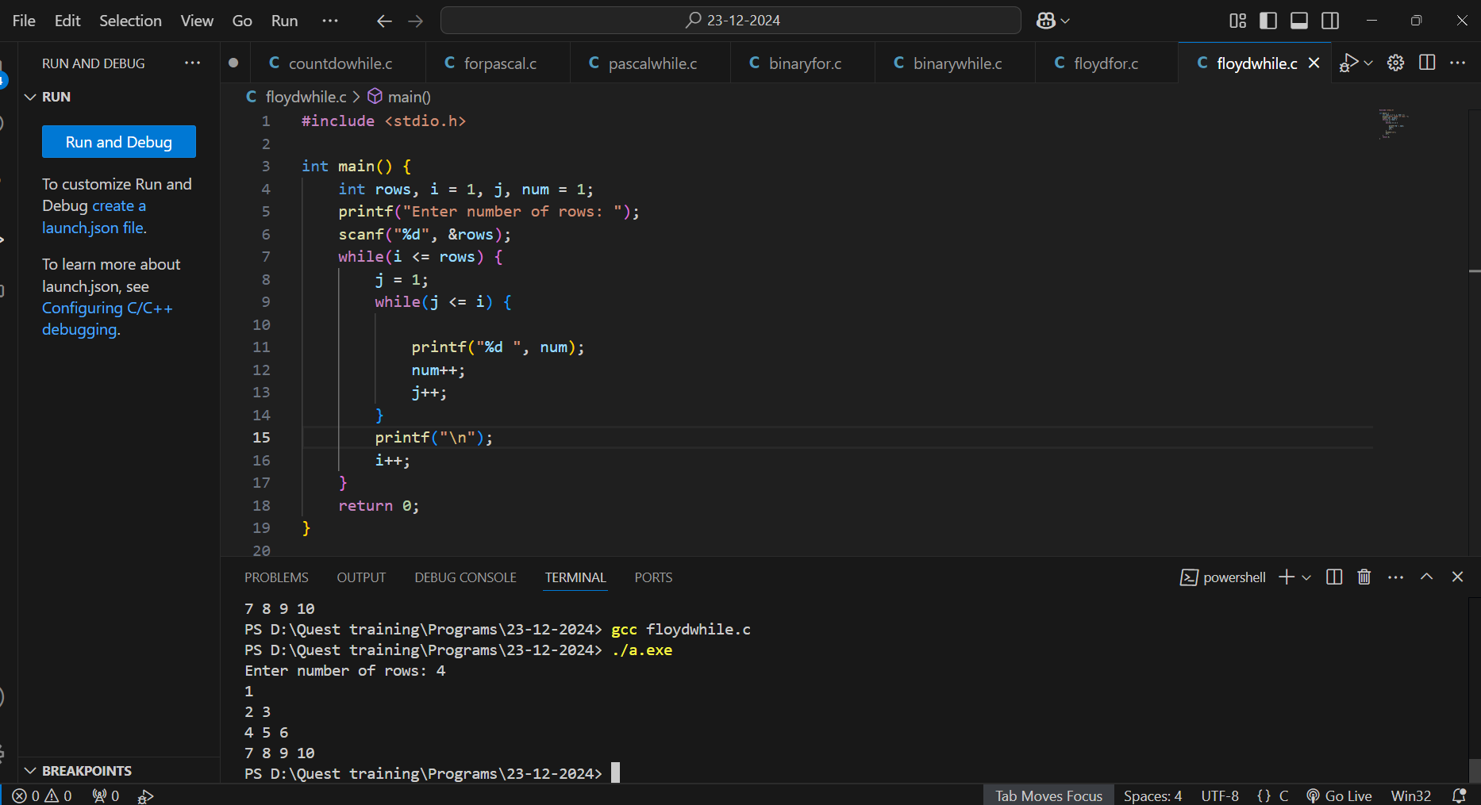

**4. Inverted Right-Angled Triangle (Numbers)**

**12345**

**1234**

**123**

**12**

**1**

**#FOR LOOP**

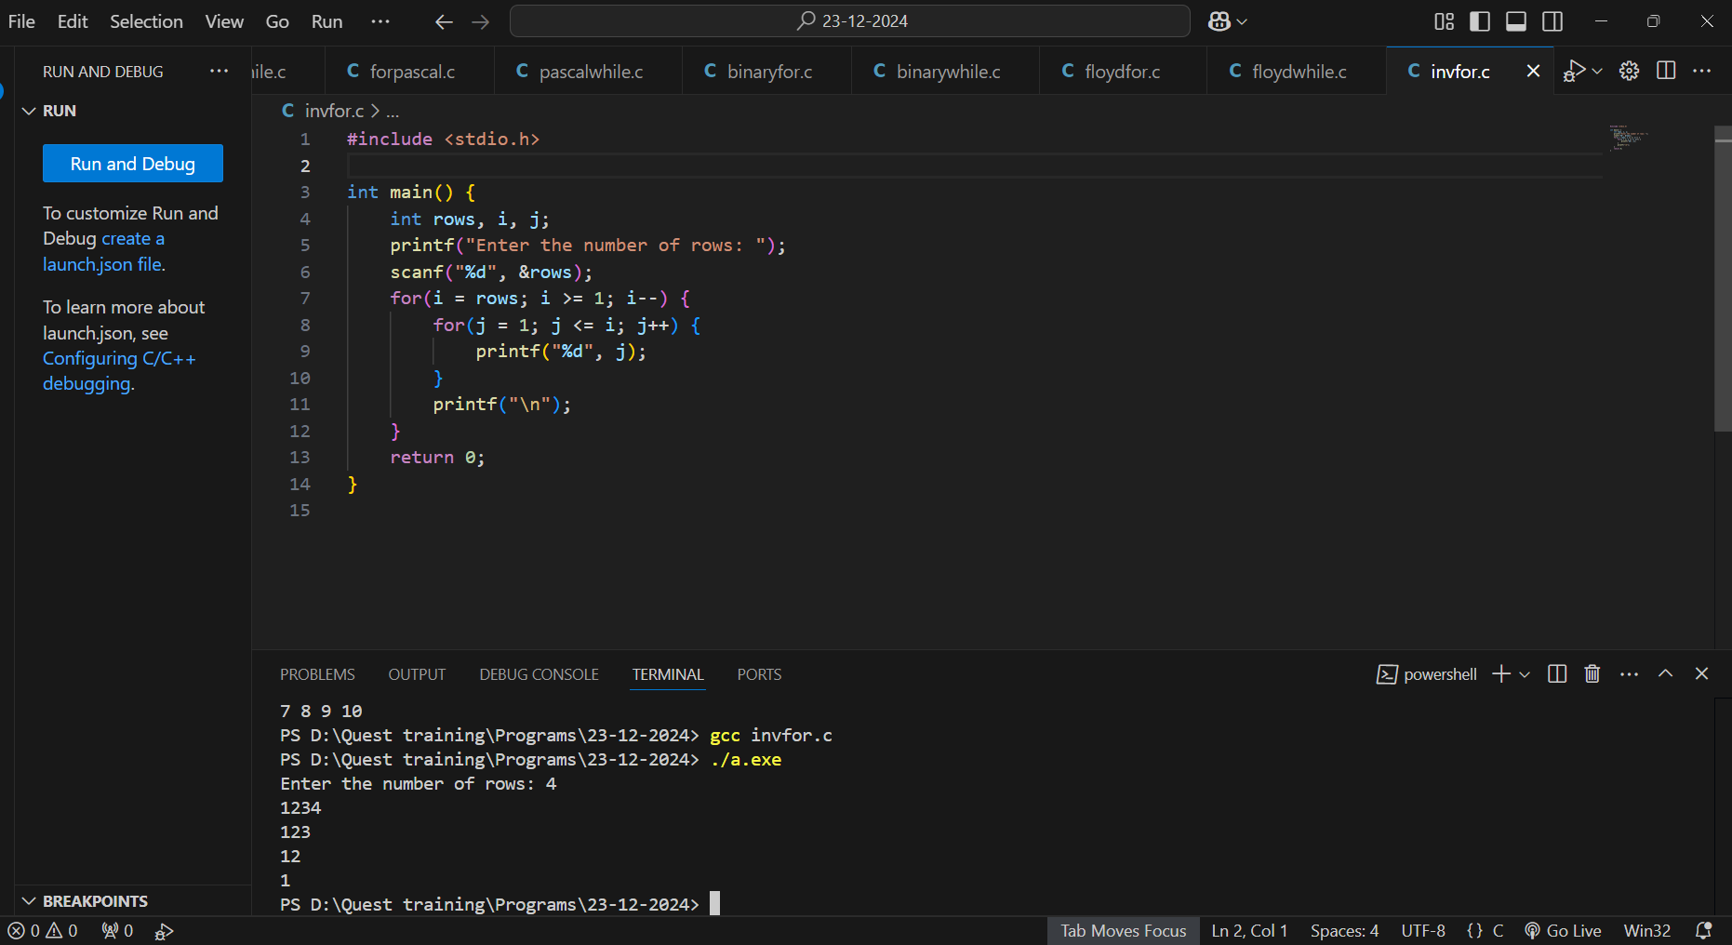

**#WHILE LOOP**

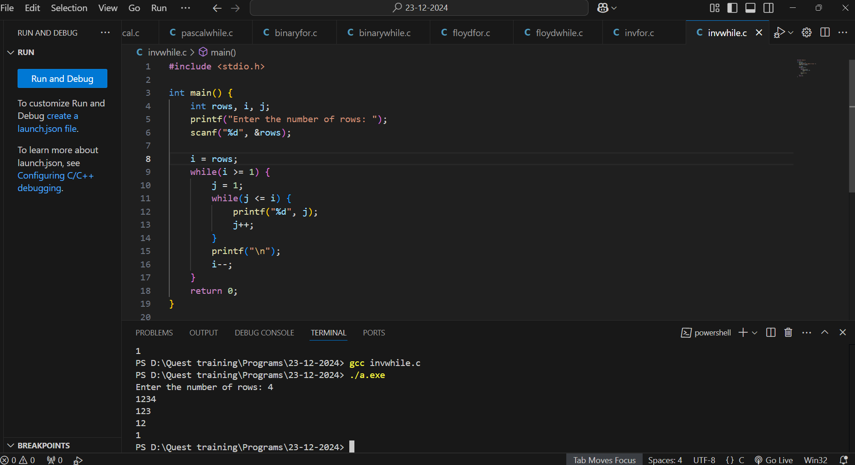

**5. Diamond (Stars)**

**\***

**\***

**\*\*\***

**\*\*\***

**\*\*\***

**\*\*\***

**\*\*\***

**\***

**\***

**#FOR LOOP**

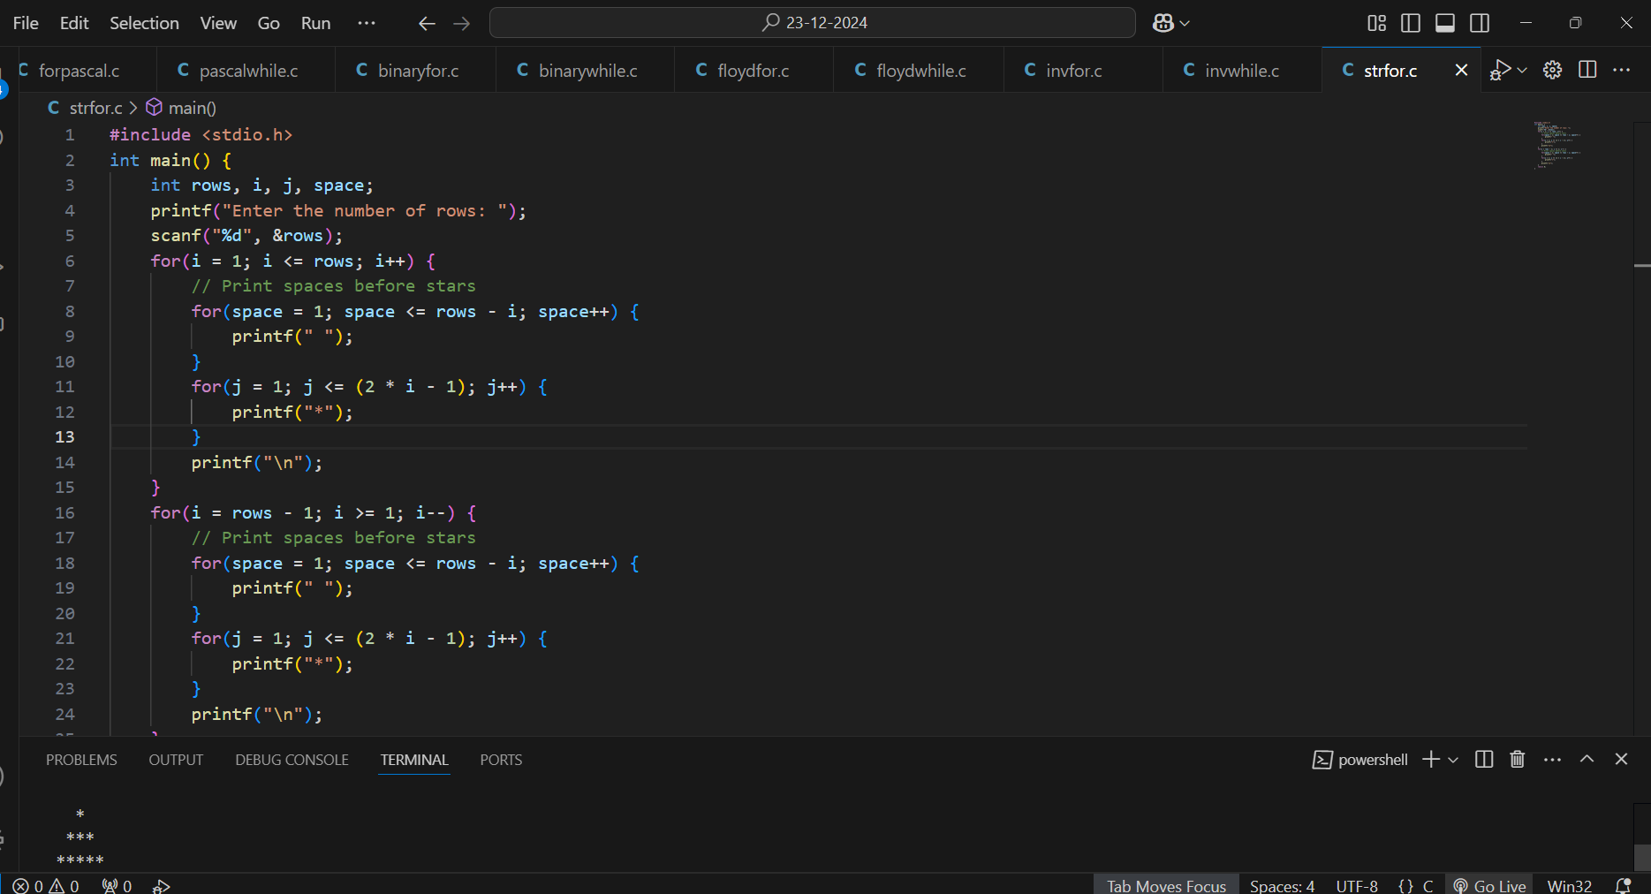

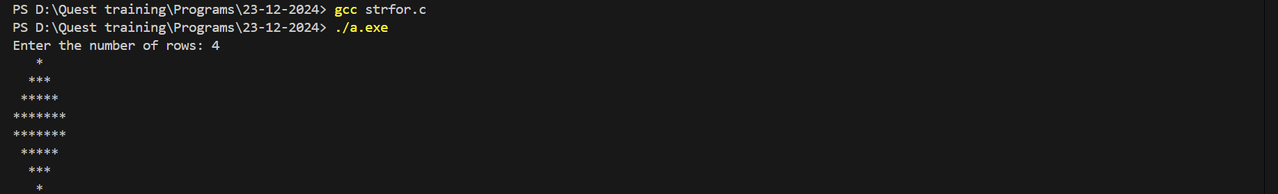

**#WHILE LOOP**

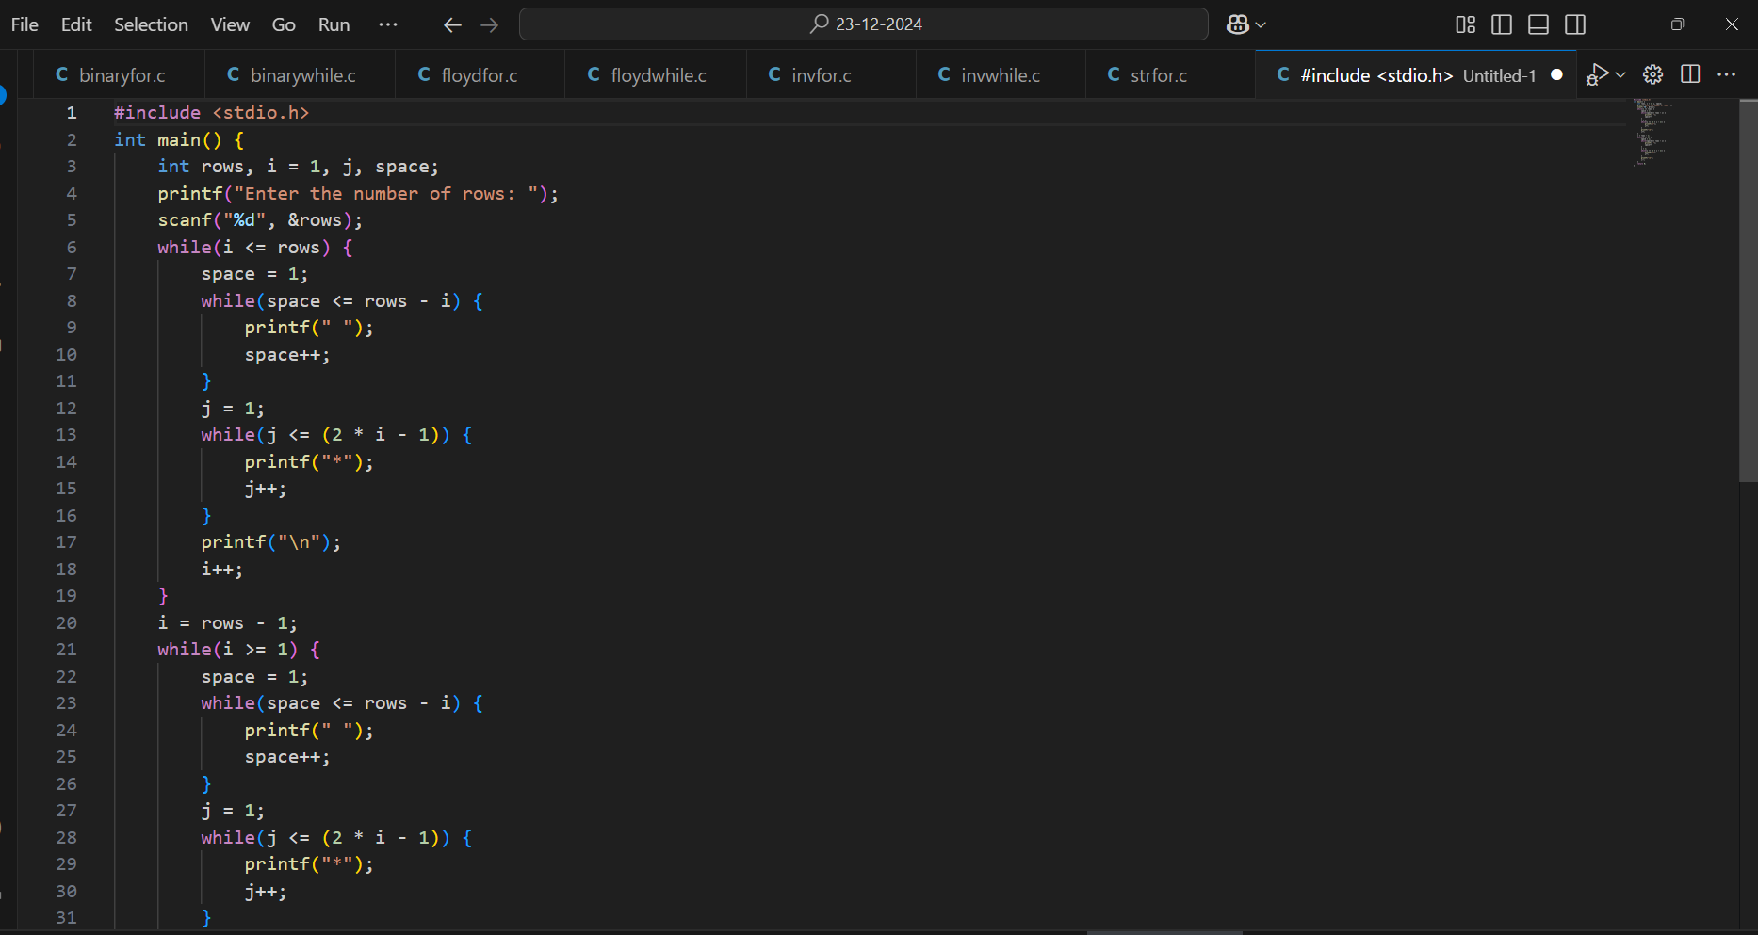

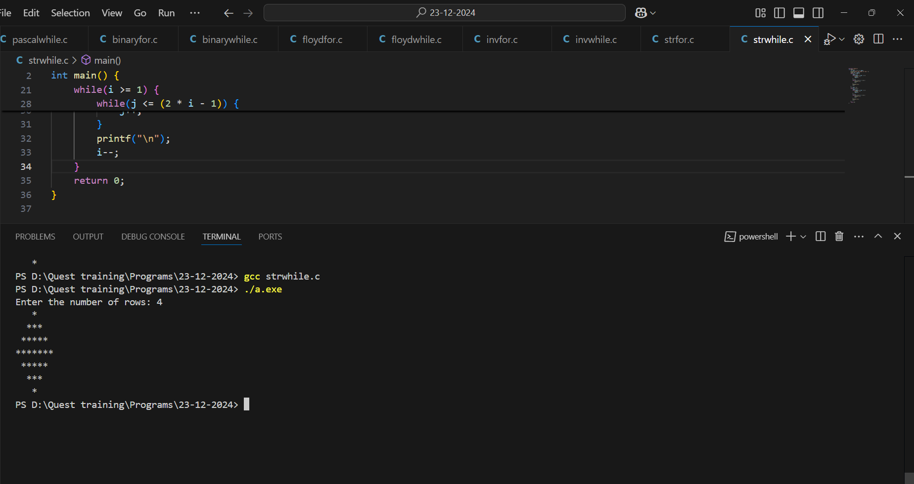

**6. Inverted Pyramid (Stars)**

**\*\*\***

**\*\*\***

**\*\*\***

**\***

**\***

**#FOR LOOP**

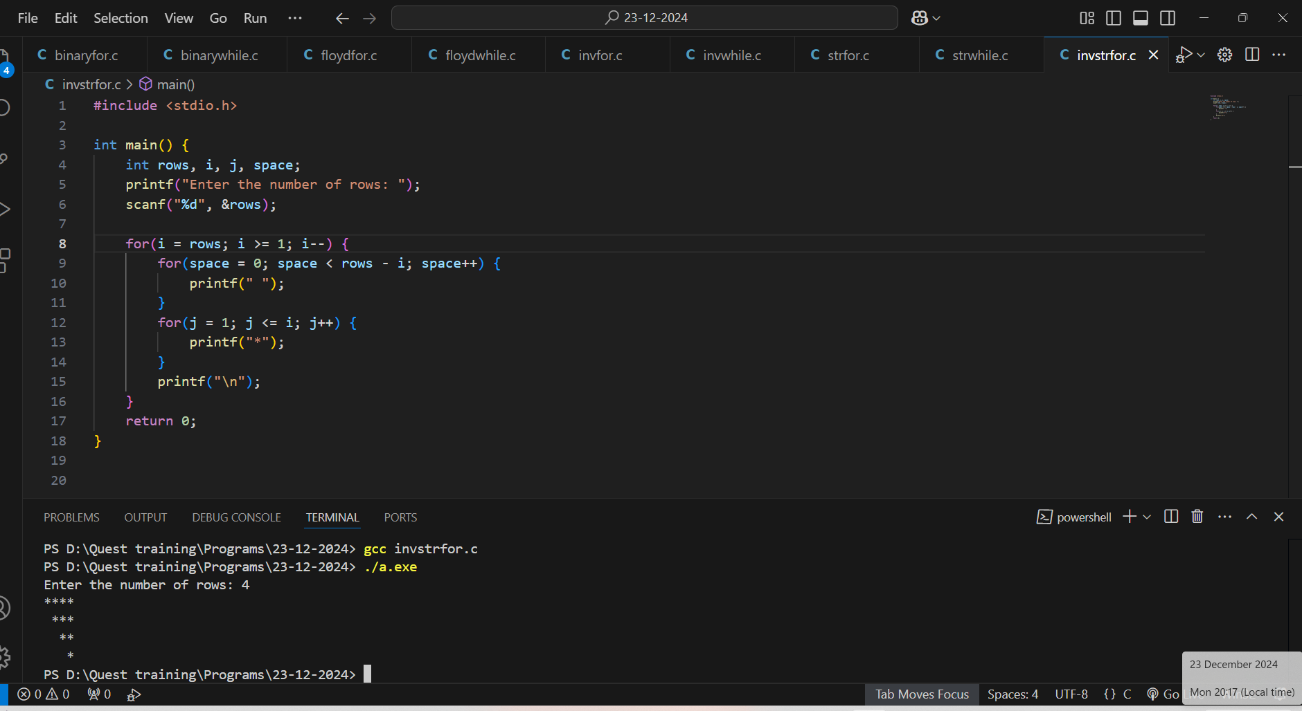

**#WHILE LOOP**

